Contents

About US 2

Our Aim: 3

**Summary:** 5

**Case study** 7

case study 10

Product/Solution 13

Product/Solution 16

Product/Solution 19

Product/Solution 21

Services 23

Services 25

About US, Solution & Case Study 29

About Us & Solution 45

Anusha V

# About US

[About Solar Monitoring](https://chat.openai.com/#:~:text=What%20is%20solar%20monitoring)

* Solar monitoring refers to the practice of continuously monitoring and analysing the performance and output of a solar power system. It involves the use of monitoring devices, sensors, and software to collect data on various parameters related to the solar energy generation process.
* Solar monitoring systems are typically installed in solar photovoltaic (PV) installations, whether they are residential, commercial, or utility-scale projects. The main objective of solar monitoring is to ensure the efficient and optimal functioning of the solar power system, as well as to identify any issues or anomalies that may arise.
* The photovoltaic monitoring system has a dashboard feature, which allows users to access all of the assets’ data in one place desktop application. The recorded data is shown in the form of a graph, and alerts which are issues present at site can be seen in these systems. They are also sent through email as per necessity.

[Why Believe Us:](https://harksys.com/about/#:~:text=See%20more-,Our%20Mission,-We%20believe%20that)

* We invest heavily in innovation, analyzation and estimation with an aim to maximize client asset value (energy production, financial performance, process optimization). Our goal is to help our clients to harness the value of renewable data with Industrial IoT, data analytics.
* While there are many good tools to analyse energy data, today there a very few organizations that provide an easy way to connect to systems and provide this information simply, in a single place. This ultimately means there are potential efficiency and asset optimisations go unnoticed and cost valuable time and money.
* We believe that solving this is critical for businesses with large estates and lots of physical assets that use a lot of energy, especially for large Energy Plants.

[Who are We:](https://www.amerescosolar.com/about-ameresco-solar-what-we-do#:~:text=Design%20and%20Engineer%20Off%2DGrid%20Solar%C2%A0Power%20Solutions)

* Libsysinc is an enterprise-scale company that utilizes technology to connect, monitor and manage energy and asset at remote infrastructures. With us, you can centrally automate business operations, utilize energy intelligently, manage asset health, optimize transportation and remotely secure and control your business environment.

[Our Management](https://www.coursera.org/articles/team-management#:~:text=What%20is%20team%20management%3F) Policy:

* Our company’s culture is pivotal in shaping good leaders and employees. It also motivates them to work together to achieve a common goal.
* Additionally, a pleasant company culture drives performance, delivers favourable outcomes, and helps employees to adapt quickly to market trends and competitors’ strategies.
* Team management refers to actions, strategies, or methods that brings a group of people together to work effectively as a team and achieve a common goal. There are many tasks that require multiple people, so teams are an essential building block to productivity. Companies rely on teams and effective team management to maintain its operations.
* 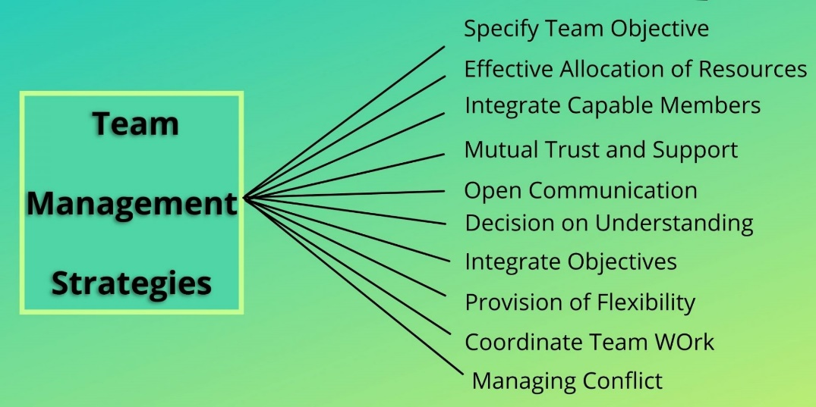Pitfalls like ineffective communication or lack of effort by a team member can derail a team’s progress. Team management helps incorporate checkpoints for teams to successfully start. It also helps maintain a good working relationship and momentum throughout the team’s life until the goal is met.

Srinivasa K

# [Our Aim:](https://corporate.solaredge.com/en/sustainability/powering-clean-energy)

* Our Company’s founding vision was to transform energy markets and change the way energy is harvested. We have relentlessly worked on the most advanced technologies to bring efficient renewable energy solutions to markets, our customers, our end-users as well as for the good of the planet.
* Our solutions support the worldwide transition from centralized, fossil fuel-based energy to clean, distributed, and renewable power generation and consumption. We help in maximizing PV power generation, storage, and self-consumption, making solar energy available to more people in more places.
* Our solutions support Climate Change mitigation efforts, and other supported negative global phenomena. This includes the minimization of harmful impacts to biodiversity.

[What is our Importance:](https://www.solarmaxx.co.in/importance-of-remote-solar-monitoring/#:~:text=A%20Remote%20Solar%20Monitoring%20System,of%20a%20solar%20power%20plant.)

A solar project is said to be complete when it starts working for you rather than us working for it and with proper monitoring of your solar system you can be assured of its best performance.

Having a proper solar power output from your system requires [efficient equipment](https://www.solarmaxx.co.in/solar-power-solutions/pv-modules-range/) and a number of other factors to support your systems effectiveness. Too much shade, dirt, damaged parts etc can cause a system to generate less electricity than it is capable of. Therefore, it is important to carefully watch your solar panel production closely so that you can identify issues as and when your system is not performing as its best.

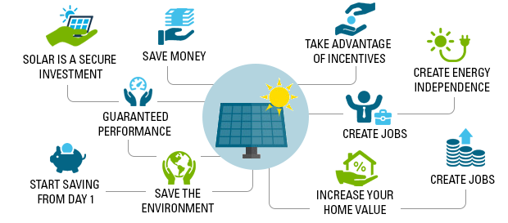

[Importance of Solar Monitoring](https://smartcityresearch.iiit.ac.in/assets/img/focus/solar/solarImage2.png)

Apart from showing energy consumption and generation data, monitoring systems also offer many tools to help you understand your solar setup. Remote monitoring companies can also help detect problems and defects with panel strings and recommend repairs to your setup. One can also track historical data from the system. For example, we offer data on historical weather-based performance, so you can know how the weather has impacted your solar production in the past, and what you might expect in the future.

With the right kind of remote monitoring department, you can have the luxury to view your plant’s energy information anytime, anywhere just at a click on your smart phone or tablet. In order to ensure that you get the right quality solar monitoring solution for your system you can rely on our team of experts at Libsysinc, who help you choose the right path and make your systems remote monitoring effective. To know more, simply **contact us**.

[Role in our organization](https://corporate.solaredge.com/en/careers):

Our culture sets the framework for every employee to maximize their professional development to reach, and even exceed, their own personal best. We offer a high-energy open concept work environment which focuses on teamwork and collaboration where everyone is encouraged to learn from those around them.

**Our Pillars Of strength**

* Collaboration
* Community Contribution
* Innovation
* Inclusion and Diversity

Your data is always secure, and your plants monitored. We provide you with all the tools for optimizing the performance of your solar power plant. We are committed to our highly qualified team of professional **Solar Technical Analysts** whom we entrust to keep monitoring our sites up to date with the latest advances in the industry. Our record speaks for itself. While we specialize in monitoring photovoltaic solar power plants, we also perform deep dive analysis of plants and prepare reports which consists of the total production, losses, string data etc.., of your solar power plant .

[What does a Solar Technical Analyst do](http://www.cleanpower.com/wp-content/uploads/Renewable-Energy-Technical-Analyst.pdf)

* Determining effective capacity of non-dispatchable energy resources on the grid
* Calculating power variability from PV systems in an ISO territory ▪
* Comparing the accuracy of satellite-based solar irradiance forecasts against ground-based measurements
* Calculating the value of solar by estimating utility savings in fuel, capital, and O&M
* Designing solar tariffs and incentive programs
* Evaluating energy storage resources to meet forecasted load growth.

[Sustainability:](https://www.mdpi.com/2071-1050/13/15/8120)

* Solar photovoltaic (PV) is one of the prominent sustainable energy sources which shares a greater percentage of the energy generated from renewable resources. As the need for solar energy has risen tremendously in the last few decades, monitoring technologies have received considerable attention in relation to performance enhancement.
* Recently, the solar PV monitoring system has been integrated with a wireless platform that comprises data acquisition from various sensors and nodes through wireless data transmission. However, several issues could affect the performance of solar PV monitoring, such as large data management, signal interference, long-range data transmission, and security.

**The architecture of the solar PV monitoring system can be divided into three levels:**

1.Data acquisition level: In the data acquisition level, the data are collected from the various sensors such as voltage, current, temperature, humidity, irradiance, etc., and are then sent to the next stage using either the wired or the wireless system

2.Data processing level: In this level, the data are stored temporarily in auxiliary devices such data loggers, processed, and sent to the last stage for the display of the results.

3.Data display and storage level. In the last level, the data are received by the workstation and then the required actions are taken by the system to be configured accordingly. These data can be accessed from anywhere at any time via the internet.

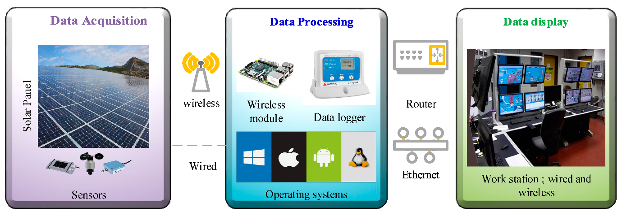

[Sustainability Initiatives:](https://www.renovainc.com/en/sustainability/solar/#:~:text=PV%20Power%20Generation-,Examples%20of%20Sustainability%20Initiatives%20in%20Solar%20PV%20Power%20Generation,-RENOVA%20places%20emphasis)

**Initiatives to Achieve Carbon Neutrality**

* Solar PV power generation does not produce CO2 emissions because it generates electricity using only solar energy.
* It does not produce any other waste, wastewater, noise or vibration associated with power generation.
* Monitoring green electric power generated by solar PV will contribute to our efforts in achieving its goal of carbon neutrality by 2050.

**Global and Regional Environmental Initiatives**

**Maintaining Local Environments:**

We are engaged in initiatives to minimize the impact of the power plants on local environments as much as possible. To preserve as much of the natural surroundings of power plant sites as possible, we make maximum effective use of the natural the topography of the land while performing analysis of sites

Charishma

# [**Summary:**](https://teltonika-networks.com/use-cases/energy-utilities/remote-monitoring-of-solar-power-plants#:~:text=REMOTE%20MONITORING%20OF%20SOLAR%20POWER%20PLANTS)

Global political and economic initiatives are driving the demand for alternative power sources. Solar power has been the leader amongst other renewable energy sources and according to IEA will dominate growth in the next five years. With significant economic powers, such as India, China, and the EU, focusing heavily on the expansion of renewable energy, solar power will undoubtedly become one of the primary energy sources of the future.

The solar power plant consists of a sophisticated infrastructure working in perfect sync to maximize the potential electricity production. Primary components are solar panels, inverters, solar controllers and transmission or energy storage systems. The performance of solar power plants must be closely monitored to ensure the maximum productivity and availability to make sure that everything is running smoothly and the electricity generation rate is within acceptable values to satisfy project ROI* schedule.

Besides, remote monitoring is essential to scheduled maintenance, such as part replacement or solar panel cleaning, required for the power plant to maximize long term performance. Solar power plants are mostly located in remote areas because of the large amount of land area they occupy. Remote location poses a challenge for remote monitoring connectivity because wired Internet sources are rarely available at solar power production plant locations.

[Advantages](https://solyntaenergy.com/2018/01/06/top-five-benefits-of-solar-monitoring-systems/#:~:text=Get%20Started-,Top%20Seven%20Benefits%20Of%20Solar%20Monitoring%20Systems,-0)

* The biggest benefits of energy monitoring systems are their easy use, remote functioning, as well as acting as huge money savers in the long run.
* Detect problems with your solar home systems when they occur by sending you an alert when performance is nose-diving.
* Track how much electricity you use
* Compute and quantify your savings on electricity
* Compute and measure your carbon reduction or off-set
* Increase performance
* Ensure regular maintenance
* Save time and increase efficiency

[Features of our company :](https://www.qosenergy.com/about/#:~:text=Harness%20the%20Power%20of%20Renewable%20Energy%20Data)

Independence, agility & innovation

Our company strategic positioning is to provide impartial decision-making solutions to our customers. Our support and consulting services are focused on our customer’s best interests with the highest level of confidentiality.

Continuous development, innovation & research

We invest heavily in innovation with an aim to maximize client asset value (energy production, process optimization). Our goal is to help our clients to harness the value of renewable data.

Support, training, and assistance services to accompany along the way

Our team of multi-lingual engineers is dedicated to maximizing client asset value by providing data analytics solutions, day-to-day consulting, and support services.

[What We Believe in](https://3e.eu/about#:~:text=We%20believe%0Ain%20renewable%20energy%0Afor%20all%2C%20at%20any%20time%0Aat%20any%20place.)

Renewable energy ​for everyone, everywhere.

​In the future, we envision a world powered entirely by clean, sustainable energy. We believe that solar and wind can power all of our homes, vehicles and businesses via the electrical grid - while also feeding the production of green fuels to drive heavy industry and commercial transport.

​Through the continual development and innovation of the last few decades, renewable energy investment is now the most cost-effective and sustainable choice. Solar PV is already the world’s cheapest electricity source.

Driven by our unwavering ambition to maximise renewable energy generation around the world, we hold all of our work to the highest possible standards. As a company dedicated to addressing the climate crisis, uplifting our employees, and empowering communities, we're meeting investors’ growing need to align their portfolios with their values.

Driven by our unwavering ambition to maximise renewable energy generation around the world, we hold all of our work to the highest possible standards. Our products and services are the result of decades of research and development - performed both in-house and via our partnerships with various industry leaders. We provide out-of-the-box compatibility by leveraging important third-party solutions that are critical to your renewable project’s success.

Vihas

# [**Case study**](https://www.quadrical.ai/resources/#case-studies)

For our customer, a solar developer, operating a portfolio of solar assets brought new complexities every season, every day and every hour.

Portfolio capacity is of 160 MW, 5 plants in total area of 804 Acers located in India modules used for this plant are 491732 modules connected to 93 central inverters with having sensor level / string monitoring box (SMB) level sensors are 889 and with (WMS) sensors are of 12, and configuration with single - axis and seasonal tracker.

Solar plant operating data is stored in different databases with SCADA, each plant had different table structures, at different time ticks. This meant they needed to run custom scripts for each plant, even for every generation report.

A centralized data monitoring platform capable of providing detailed performance analytics would allow them to focus on growing their portfolio, not trying to make excel do complex work.

This is where Quadrical Ai came in. As solar Data cloud specialists, being able to visualize and monitor their whole portfolio in Realtime – regardless of data acquisition systems - SCADA, dataloggers databases, sensors, 3rd party services would make their life easier.

**Challenges**

Each plant in the portfolio naturally had a different layout, topology, and capacity, but also 3 different SCADA vendors in their 5 plants. Each database stored plant operating data in a custom schema format corresponding to its plants architecture and SCADA setup.

Plant performance reporting turned complex as each database demanded custom handling. The team tackled siloed data, data latency. Management found it difficult to visualize real time unified portfolio performance.

**Increase in operating costs:** Different sets of analysts to figure out schema for different plants directly accelerated HR requirements, resource wastage and risks of error.

**Lack of insights:** Valuable analytical insights inevitably fell through cracks resulting in inefficient operations management and financial downsides.

**Limited Visibility, information Asymmetry:** Management was completely dependent on field teams for optimizing operations and reporting due to lack of visibility. This was multiplied as they had no way of sharing best practices across plants, which was important to the company.

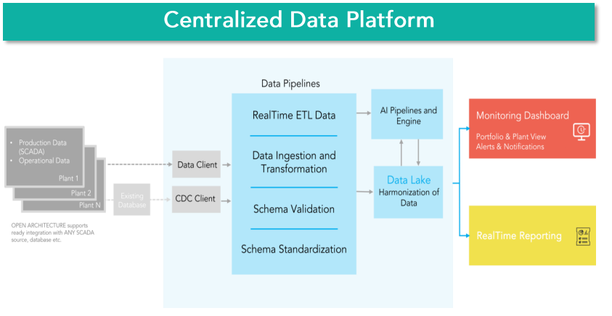

**Solution**

* Massive Data Platform running for each plant.
* Structured and standardized schema based on Real Time data.
* Real Time data visualization and analysis on entire datasets
* Reliable system benchmark with accurate, insightful data analytics

This efficient data management process meant cost savings, greater visibility, and the chance to build deeper insights which would help increase generation in the very new future.

Using this AI based platform, data could be further analyzed to issue Predictive O&M Guidance based on maximum revenue Impact.

* Revenue impact driven O&M directions
* Streamlined O&M activities to minimize downtime and optimize operating costs.
* Leveraging data-driven decision making to maximize profitability and information symmetry.

**AI Advantage**

* A single Standard Schema
* Open Architecture Integration Public API
* Zero Sync Issues
* Alerts benchmarked to AI proprietary Digital Twin Baseline
* State-of-art cloud storage and data archiving solutions

**Real-time Monitoring**

An AI Real Time Monitoring reporting helps extract the value from plant operating data by identifying and analyzing loss buckets, streamline O&M and ticketing management in a single workflow, define key performance indicators (KPIs) and benchmark plant performance with Digital Twin AI.

* Needle-in-Haystack (granularity and accuracy for catching leakage losses)
* Patterns predicting outages with no evident current loss.
* Structural issues (degraded panel, cables, equipment, and shading)
* Soiling
* Temporal (DC, Cabling, Inverter or other equipment maintenance, slackers)

With end-to-end visibility, our customer could view the entire portfolio at present and at any point in history.

They could now respond to all production impacts in Real Time and had exactly the information they needed in intuitive dashboards.

**Key Outcomes**

* Field teams get reliable data to pinpoint underperformance whenever it occurs in any plant.
* Best practices and processes can be percolated across plants and across portfolio allowing yield optimization everywhere.
* Management now has 360 degrees visibility based on benchmarked KPI’s with reliable data.
* Optimization of cloud infrastructure used to restore, backup, storage and Real Time data availability.

**Benefits**

**Set Up**

From all plants irrespective of SCADA & OPC implementations. No more delays or missing/lost data, but Real Time with integrated archiving in cloud.

**Managements**

Real Time Portfolio Performance Monitoring & Revenue Impact.

**Finance Team**

Automated reports against standardized schema foreach site, so no more data juggling in excel.

WHITE PAPER

[What is a White Paper](https://www.investopedia.com/terms/w/whitepaper.asp#toc-purpose-of-a-white-paper:~:text=Investopedia%20/%20Michela%20Buttignol-,What%20Is%20a%20White%20Paper%3F,-A%20white%20paper)

A white paper is an informational document issued by a company or [not-for-profit](https://www.investopedia.com/terms/n/not-for-profit.asp) organization to promote or highlight the features of a solution, product, or service that it offers or plans to offer.

White papers are also used as a method of presenting government policies and legislation and gauging public opinion.

**Key takeaways:**

* A white paper promotes a certain product, service, or methodology to influence current and prospective customer or investor decisions.
* Three main types of white papers include backgrounders, numbered lists, and problem/solution white papers.
* A white paper provides persuasive and factual evidence that a particular offering is a superior product or method of solving a problem.

**Purpose of a White Paper**

White papers are sales and marketing documents used to entice or persuade potential customers to learn more about a particular product, service, technology, or methodology.

[Benefits](https://www.omnidian.com/technology/whitepaper-highlights/#:~:text=In%20This%20White%20Paper%2C%20We%20Explore%3A):

* Significantly improved workflows through remote diagnosis and targeting of high-priority alerts compared with low actionability noise (snow, temporary soiling).
* Advanced triage tools providing automated diagnosis along with production, service history and past performance, enabling rapid human intervention and service confirmation.

[Solar Monitoring Analysis:](https://www.solarpowerworldonline.com/2022/09/white-paper-optimizing-solar-and-storage-assets-with-advanced-mc-technology/#:~:text=White%20Paper%3A%20Optimizing%20Solar%20and%20Storage%20Assets%20with%20Advanced%20M%26C%20Technology)

How can AI-driven solutions unlock greater value from commercial and utility-scale projects? This Guide house Insights white paper sponsored by Stem explores how the monitoring and controls (M&C) technology market is evolving to meet the need for advanced solutions to optimize solar and storage assets both behind-the-meter and front-of-the-meter.

The research outlines how industry stakeholders should be thinking about solar and storage project portfolios and how advanced M&C technologies improve performance, create new value stream opportunities over time, and reduce asset risk.

Jayasri

# case study

**Clean energy microgrids for the commercial &industrial sector**

A growing number of corporations are going green. According to the Rocky Mountain Institute, nearly two-thirds of Fortune 100 companies and nearly half of Fortune 500 companies have set ambitious renewable energy targets.

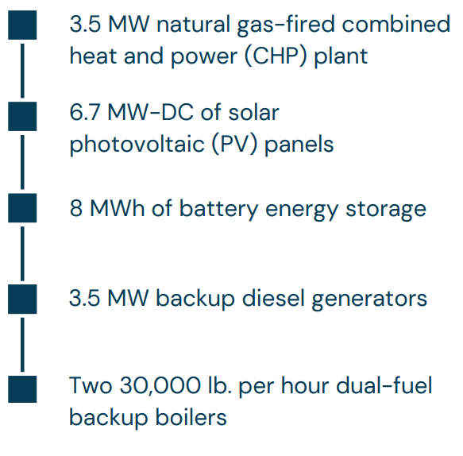

The microgrid is managed by Energy advanced Control System. This enables the overall microgrid solution to manage the supply of power and balance the fossil-fuel and renewable energy sources in accordance with loads, in a cohesive and coordinated manner, preserving access to utility-grade power at all times. During normal operation, power is generated by the PV plant, supplemented by the grid. In event of an outage or power quality issue, the microgrid enters island mode, with a motorized circuit breaker opening to avoid feeding power back into the grid. Using its unique virtual generator capabilities, the PowerStore Battery Energy Storage System forms the grid and provides power to the load while maintaining utility-grade power quality for the site. For extended outages, one or both generators start automatically whenever needed, ramps up in speed and share the load with the PV plant and the PowerStore. The main purpose of the compact and versatile PowerStore battery energy storage system (BESS) is to stabilize the power system against fluctuations in frequency and voltage. It does this by rapidly absorbing or injecting power. Prior to installing the microgrid the facility suffered from an average of 10 voltage dips per month, negatively impacting production. The PowerStore mitigates these fluctuations so productioncan continue uninterrupted no matter the issues in the distribution grid. State of the art inverters with virtual generator mode capabilities have been deployed that make it possible for the diesel generators to be switched off for most of the time. The solution can also ensure a seamless transition from grid connected to island mode when there are outages on the grid. A cloud-based monitoring system enables remote operation and maintenance of the microgrid, in keeping with Hitachi Energy’s Industrial Internet of Things approach.

API release provides easy access to data

<https://www.clir.eco/blog/api-release#:~:text=API%20release%20provides%20easy%20access%20to%20data>

Clir’s new API enables easy access to data processed by our best-in-class data model and enriched with insights generated from over 200 GW of market intelligence.

* This enables our clients to use our enhanced portfolio data and market intelligence for all their needs, wherever they arise, through easy access and controllable integration to other third-party software providers.

What is an API?

* API is the acronym for Application Programming Interface, which is a software intermediary that allows two applications to “talk” to each other. The API is the menu that allows for concise communication, establishes expectations and facilitates information delivery between the two parties.

Why was it created?

* By creating an API, Clir users now have access to data whenever they want. This will help drive weekly and monthly reporting that joins to third party data (pricing, financial, OHS, ticketing, etc.) in third party systems such as data science workbooks, custom dashboards, and PowerBI or other BI tools. It will also provide:
* The ability to access as little or as much data as you like.
* Up-to-date analytics and automated reporting.
* Easy integration with other forms of data so they can aggregate reports including financial or other data.

**How will this benefit clients?**

* Our API provides a host of benefits for Clir’s clients, including:
* Ability to leverage data enriched with insights from over 200 GW of industry intelligence across your workflows.
* Includes pre-calculated KPIs commonly used by the industry, such as production, wind speed and availability. This reduces human error, as customers do not have to calculate the KPIs themselves, and enables consistency with data in the Clir app.
* Data is readily available in business intelligence/analytic tools without having to be imported.
* Data can be more easily joined and amalgamated to other sources, like financial data.
* Enables analytics that keep themselves up to date, like dashboards or Jupyter Notebooks, and automated reporting.
* Reduces time to extract data from Clir’s App after initial integration.

**Clir Renewables' anniversary: Five lessons from our first five years**

<https://www.clir.eco/blog/clir-renewables-anniversary-five-lessons-from-our-first-five-years#:~:text=Clir%20Renewables%27%20anniversary%3A%20Five%20lessons%20from%20our%20first%20five%20years>

Reflecting on five years of Clir Renewables, we’ve accomplished a lot. We’ve added over 200 GW of wind and solar data to our platform, we’ve worked with clients from 17 countries across the globe and we’ve grown our team to over 125 experts worldwide. During that process, we’ve learned a lot of things: how to build a product, enter new markets and help humankind reduce its impact on the environment. We’re celebrating our five-year anniversary with lessons from our first five employees who have helped us grow from a small startup in Vancouver to a global, industry-leading CleanTech company.

**Understand the problem and be passionate about the solution**

<https://www.clir.eco/blog/clir-renewables-anniversary-five-lessons-from-our-first-five-years#:~:text=Lesson%201%3A%20Understand%20the%20problem%20and%20be%20passionate%20about%20the%20solution>

We started Clir Renewables because of a clear problem in the way wind farms were managed: there were inadequate data-reporting tools and conflicted turbine manufacturers protecting their internal know-how. Having worked as consultants for over a decade, we understood this issue deeply. We also understood the implications of this problem — poor operations led to lower annual energy production and fewer investments into the industry. We wanted to find a solution that would help increase reliance on renewable energy and reduce humankind’s impact on the environment. Understanding the problem, and having the passion to solve it, helped us build a better solution.

**Hire people better than you**

<https://www.clir.eco/blog/clir-renewables-anniversary-five-lessons-from-our-first-five-years#:~:text=Lesson%202%3A%20Hire%20people%20better%20than%20you>

In the early days, you’ll love the fact that you wear every hat at work: full-stack developer, DevOps, data engineer, product manager and more. But there are a few problems with this approach:

• You’re doing too much and you probably suck at most of it.

• The weight of those responsibilities will crush you.

As your business grows, so should your team. When it’s time to hire people in to help, here are a few things to consider:

* Hire people that make you uncomfortable. Hire people that will challenge you. We all have weaknesses and vulnerabilities, and it can be uncomfortable to have them exposed. At the same time, it’s a great way to learn and a great motivation for improving in those areas.
* Hire people that are fearless. Some of the fearlessness could be ignorance about the enormity of the problem — as was the case for me — and some is ambitiousness. Whatever the reason, you want people who are excited at the prospect of having real ownership and responsibilities, and who will rise to the challenge.

Deepak

# Product/Solution

[**Performance Reports**](https://www.apolloenergyanalytics.com/products/predictive-analytics.php%23:~:text=to%20know%20automatically.-,Performance%20Reports,-The%20Apollo%20performance)

The performance reports enable high automation for Asset Owners by sending pre-configured reports to the relevant stakeholders as desired. Be it an Failure prediction alert or a performance summary we do all of it.

Solar monitoring helps solar customers pinpoint the time of day when their panels are at peak performance. Knowing peak performance times can also help you maximize your use of that energy. The hardware on solar monitors might also measure solar radiation and other weather data.

PRODUCTS BY USER

<https://www.apolloenergyanalytics.com/products/asset-owner.php>

[Portfolio Performance](https://www.apolloenergyanalytics.com/products/asset-owner.php%23:~:text=report%20for%20CXO.-,Portfolio%20Performance,-Dashboards%20to%20view)

Dashboards to view portfolio Performance across sites as compared to the budgets and simulations - in addition unlock the value of AI with the Predicted Digital Twin output which tells you the potential gain opportunity that exists.

[Centralised Dashboard](https://www.apolloenergyanalytics.com/products/asset-owner.php%23:~:text=Centralised%20Dashboard)

Track equipment and plant level performance data through customizable dashboards with widgets suitable for roles such as CXO, engineering, operations and finance.

[The core of your Insights and analysis will always be your raw data](https://www.apolloenergyanalytics.com/products/asset-manager.php%23:~:text=THE%20CORE%20OF%20YOUR%20INSIGHTS%20AND%20ANALYSIS%20WILL%20ALWAYS%20BE%20YOUR%20RAW%20DATA)

<https://www.apolloenergyanalytics.com/products/asset-manager.php>

The Company has a cleaning algorithm that focuses on giving the users clean, verified, quality data with simple visualization and reporting access.  ensures clean data since we pick up data from the edge and push it all the way to the cloud, ensuring the store and forward as well as the validation of the data. In addition to the custom data analysis capability using custom charts or reports. The platform comes with ready to use Analytics tools at your disposal.

[**Building Good Energy**](https://www.solvenergy.com/%23:~:text=Building%20Good%20Energy)

At SOLV Energy, every individual is passionate about improving our home through high-quality renewable energy. That’s why we’re invested in building and managing state-of-the-art energy systems and storage solutions that maximize production for optimal results. Each project is an opportunity to provide cleaner power, better jobs, greater education, and a brighter future for our community.

<https://www.solvenergy.com/>

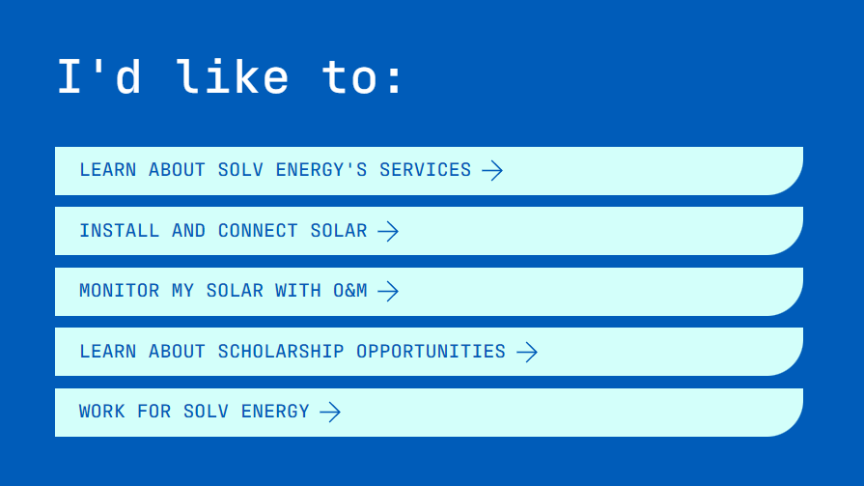

SOLV Energy has a can-do attitude. They build projects and solve problems in an expedited, efficient, well-built way…For us there is a seamless integration: SOLV Energy says they’ll build it, SOLV Energy says they’ll operate it, and then they deliver top quality work.

[**Building Better Tools**](https://www.solvenergy.com/expertise/technology%23:~:text=Building%20Better%20Tools)

We’re no longer waiting or working off outdated data. From intuitive recreations of massive solar farms to GPS tracking to easily understandable installation legends and beyond, better information is at our fingertips and enabling us to complete projects more efficiently. Because of Sunscreen, we’re able to build better, faster, and provide the high-quality customer service our clients have come to expect.

[**Vital Data**](https://www.solvenergy.com/expertise/technology#:~:text=Vital%20Data%20Delivered)

To quickly assess system performance without slowing energy production, we developed Vitals. This web-based platform examines operational information at all levels. Through advanced data analytics, our field technicians identify issues and review details easily and efficiently—regardless of the site’s size.

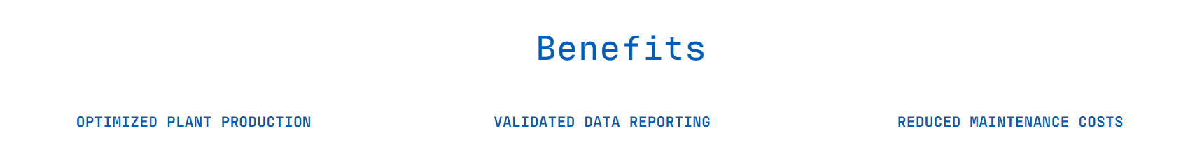

**[Solar Scada](https://skyfri.com/" \l "SolarSCADA:~:text=Skyfri%20Intelligence-,SolarSCADA,-All%20inclusive%20solar)**

Fully integrated SCADA designed for solar assets. A pre-commissioned system, ready to install, with simplified sensor install, calibration & maintenance for monitoring-instruments.

## Features

Complete operational and financial overview in real-time

Loss buckets categorized and reported through alarms

Performance against base case or estimates, with integrated weather forecast

* Digital twin (string level)
* Dynamic benchmarking
* Single window view of most important parameters

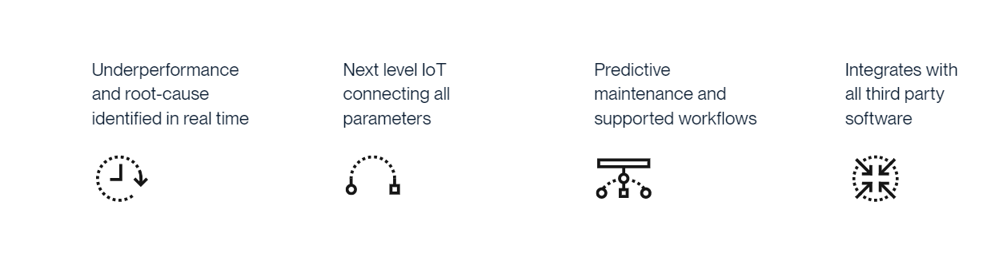

[**Conclusion and Future Work**](https://www.google.com/search?q=conclusion+for+solar+monitoring+system&rlz=1C1GCEA_enIN1034IN1034&sxsrf=APwXEdcaeuu3X2e5MASUF1bnHHmSTADj2A%3A1683711719310&ei=52ZbZI3MEsKOseMPxpqD6AI&oq=conclusion+for+solar+moni&gs_&sclient=gws-wiz-serp%23:~:text=CONCLUSION%20AND%20FUTURE%20WORK)

This system is cost effective. The system efficiency is about 95%. This enables the efficient use of renewable energy. The temperature sensor helps to analysis the storage of the solar energy.

Solar energy is a clean, pollution free and renewable source of energy. Development of this source of energy requires an accurate detailed long-term knowledge of the potential taking into account seasonal variations.

Internet of Things (IoT) driven framework is aimed at getting an ideal power output from the solar panels, in this project. The different solar panel parameters like voltage, current and temperature are displayed on the LCD by using this IOT technology. The daily, weekly and monthly analysis becomes simple and efficient, as this system keeps continues track of the solar power plant. With the help of this analysis, it is possible to identify any issue occurred within power plant as there would be discrepancy in the information produced by the framework. Solar panel is worked at its maximum efficiency the entire day, by the solar tracking

The controller needs an external source to work, however, by means of the power generated by the solar module itself, the controller’s input supply of the power can be met. Dual axis solar panel tracking can be done, for very large solar panel. It is possible to foresee the future predictions of parameters, by analysing the information. Using various machine learning algorithms, Artificial intelligence this can be implemented, so that the system can turn out to be smart enough to take decisions about information and performance

Anusha K

# Product/Solution

[Solar panel Monitoring](onenote:https://libsysit-my.sharepoint.com/personal/anushak_libsysinc_com/Documents/Documents/Anusha/New%20Section%2036.one#Grafton II - Inverters 5.4B&section-id={40514150-916A-46BA-A4FE-46BD6393A883}&page-id={834D23EF-897D-40B4-9446-D3096A1EFBF7}&object-id={EF64AB87-8294-4393-A802-23F12F891650}&C)

* Our monitoring platform evaluates a solar system's overall health performance and production.

[Solar panel Reporting](https://www.mcpower.com/solar-panel-operations-maintenance/monitoring-system-reporting/#:~:text=Solar%20Panel%20Reporting)

* Through real-time data collection and monitoring, MC Power Companies provides customized reports for a solar system’s output. For even more control, we train staff to create customized reports and monitor the system.

[Measurements required for PV monitoring Platform](https://www.energy.gov/femp/monitoring-platforms-solar-photovoltaic-systems#:~:text=Direct%20Measurements%20Required%20for%20a%20PV%20Monitoring%20Platform)

Electrical measurements include:

* Real power and reactive power—Real power is consumed and measured in units of kilowatts, and reactive power flows back and forth (mainly due to the coils in motors).
* Voltage and current at the level of the whole PV system, each inverter, each series string of PV modules, or each PV module.

Weather data and satellite data are increasingly used in monitoring platforms instead of on-site measurements of environmental conditions. Environmental conditions include:

* Incident sunlight
* Ambient temperature
* PV module temperature.

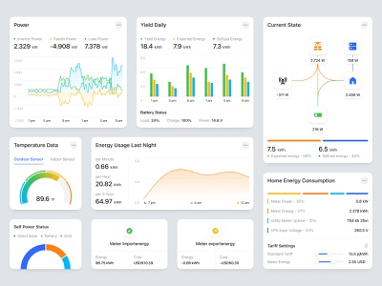

[Dashboard-Key features](https://poweramr.in/remote-monitoring#:~:text=Dashboard%2D%20Key%20Features)

* Centralized Remote Monitoring helps eliminate the dependency of OEM monitoring tool.
* Monitor PV Power Plant locally/ remotely at each stage of power plant.
* Get key updates based on generation and efficiency-based parameters like Performance.
* Ratio, CUF, specific yield, specific power which are important to track the working and know the efficacy of plant.
* Full Visibility of your system’s performance through Real Time Single Line Diagram, interactive charts, and site layout.

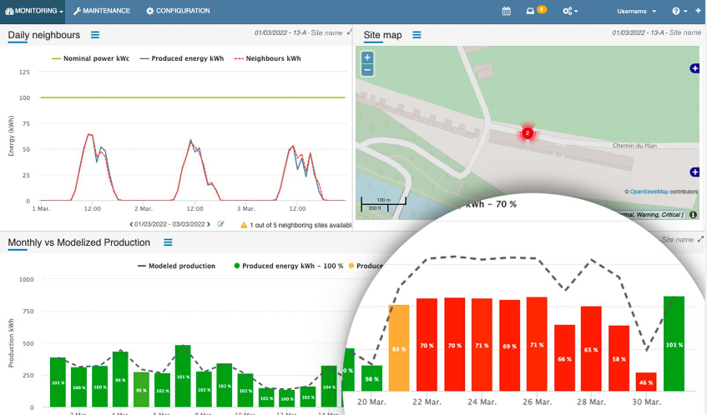

[Key Solution Features](https://poweramr.in/smart-metering-dlms#:~:text=Key%20Solution%20Features)

* Real Time Power Monitoring
* Access anywhere, anytime through Web portal
* Data Historian for quality analysis
* E Mail Reporting
* Easy and Fast Integration with any Smart meter

[Calculations and analysis](https://www.energy.gov/femp/monitoring-platforms-solar-photovoltaic-systems#:~:text=Calculations%20and%20analysis)

* Data interpretation based on comparison with neighbouring systems or by comparison with a computer model based on PV system description and environmental conditions.

[Reports of key performance](https://www.energy.gov/femp/monitoring-platforms-solar-photovoltaic-systems#:~:text=Reports%20of%20key%20performance%20indicators)

* Monitoring platforms can provide reports of availability and performance ratio. Platforms can host reports on websites or push reports to stakeholders by email.

[Errors and Alarms](https://www.energy.gov/femp/monitoring-platforms-solar-photovoltaic-systems#:~:text=or%20reduced%20output.-,Errors%20and%20alarms,-%E2%80%94Monitoring%20platforms%20can)

* Monitoring platforms can inform operators of abnormal conditions and faults that require immediate attention. Platforms can issue alarms by email or text messages.

[Issues and track maintenance tickets](https://www.energy.gov/femp/monitoring-platforms-solar-photovoltaic-systems#:~:text=Issue%20and%20track%20maintenance%20tickets)

* Monitoring platforms can allow users to issue maintenance tickets to address identified problems and to track tickets to the solution of the problem.

[Interface with utility](https://www.energy.gov/femp/monitoring-platforms-solar-photovoltaic-systems#:~:text=Interface%20with%20utility%20or%20larger%20system)

* Monitoring platforms can report required information to the utility company and may also receive signals from the utility for control of the PV system setpoints, such as curtailment of power delivery or to source reactive power when needed.

Harshith

# Product/Solution

[Monitoring complex solar PV portfolios](https://www.qosenergy.com/solution/solar-monitoring-analytics-reporting-cmms-software/#:~:text=Monitor%20Complex%20Solar%20PV%20Portfolios)

* Create personalised dashboards (technical, financial, maintenance)
* Ensure consistent high availability and performance
* Define and visualize solar plants’ key performance indicators (KPIs)
* Identify underperforming solar plants inverters, strings, or sensors
* Aggregate data for multi-energy portfolios in a single dashboard

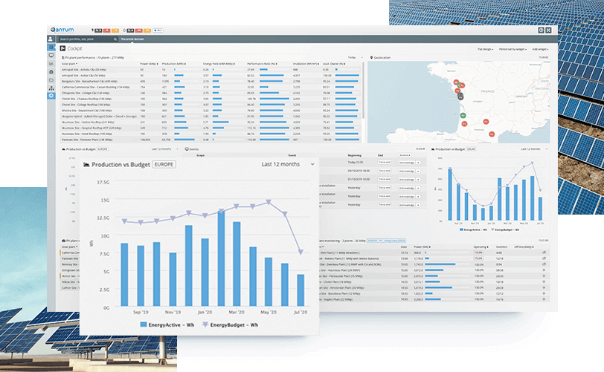

[Analyse Solar PV Plant Performances](https://www.qosenergy.com/solution/solar-monitoring-analytics-reporting-cmms-software/#:~:text=Monitor%20Complex%20Solar%20PV%20Portfolios)

* Analyse production losses in comparison with “solar digital twins”
* Be alerted in the case of an under-performance using smart alarms
* Diagnose the root-causes of underperformances (breakdown, faults, instabilities etc.)
* Visualize and categorize events affecting solar plant performances
* Customize performance analytics for every individual plant configuration (string monitoring, tracker analytics, combiner boxes, etc.)
* Enrich analytics and KPIs using data from third-party providers such as power forecast, satellite irradiance, or machine learning providers.

[Maintain your Portfolios Efficiently](https://www.qosenergy.com/solution/solar-monitoring-analytics-reporting-cmms-software/#:~:text=Monitor%20Complex%20Solar%20PV%20Portfolios)

Manage preventative and curative plant maintenance plans, react immediately in case of performance degradation. Manage reports and customize operations range and maintenance contracts.

* Optimize intervention management using the ticketing system
* Follow up incident resolutions, reduce mean time to resolution and manage intervention reports
* Manage preventive and curative maintenance plans.

[PV System Monitoring.](https://qesolar.com/services/operations-maintenance)

Highly qualified technical staff provide year-round 24/7 monitoring and analysis of PV/BESS systems, inverter and combiner level performance and have substantial experience managing portfolios with multiple monitoring solutions. Moreover, our real-time inverter and performance graphing paired with our robust internal metrics, helps identify outages or issues prior to monitoring alerts being generated and production loss occurring. We also routinely identify false alarms to minimize truck rolls whenever possible.

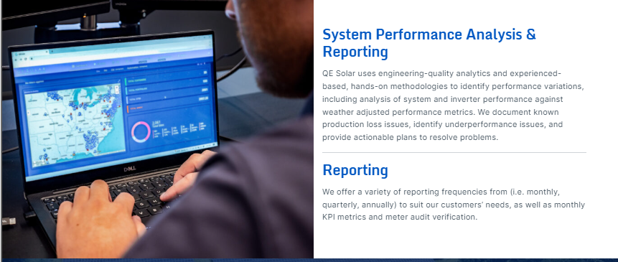

[Digital Twin based CMMS](https://www.quadrical.ai/solutions/#:~:text=UP%20A%20CALL-,Digital%20Twin%20based%20CMMS,-Your%20entire%2C%20global)

Your entire, global portfolio – more easily managed – on a trusted, cloud-based platform.

* Data aggregated from a wide variety of critical sources— SCADA, other Data Acquisition Systems, to power forecasts – with zero sync issue, state-of-art cloud storage and data archiving solutions. Standardized data migration process, managed by our Technical Team
* Centralized Data Platform with built-in Monitoring/Reporting and Advanced Analytics
* Expert support to ensure a Realtime assessment of plant performance across your complete portfolio.

[Monitoring performance of plant](https://instylesolar.com/solar-guides/what-is-solar-monitoring-and-how-does-it-work#:~:text=Monitoring%20Performance%20of%20Your%20Solar%20Unit)

* Local weather
* De-rating of power temperature
* Shading, either partial or complete on your solar unit
* Cabling and inverter failures
* Panel inclination and orientation
* Seasonal changes throughout the year

[Solar Analytics systems](https://instylesolar.com/solar-guides/what-is-solar-monitoring-and-how-does-it-work#:~:text=Monitoring%20Using%20a%20Solar%20Analytics%20System)

* Overall performance of the solar unit
* Power consumption and usage habits
* Net power purchased and sold.
* How much power your device should be producing vs. how much it really produces.
* Estimated savings and credits.
* Monitoring of grid frequency and voltage
* Diagnostics, alerts, and failures

[Track Performance](https://instylesolar.com/solar-guides/what-is-solar-monitoring-and-how-does-it-work#:~:text=you%20reset%20it.-,Track%20Performance,-The%20most%20essential)

* The most essential technique to ensuring your inverter is running properly is to consistently monitor its performance. Almost all inverter models available now can monitor ‘output,’ which is the quantity of solar energy your system creates.
* Higher-end inverters, have extra monitoring features, to maximise self-consumption of the solar electricity you create. It can automatically coordinate energy flows and improve your
* energy management.

Kusuma

# Product/Solution

[Professional service includes](https://home.alsoenergy.com/services/#:~:text=Professional%20services%20include%3A)

* Supervisory Control and Data Acquisition (SCADA) and monitoring system design, project management, and utility and local coordination for efficient commissioning
* Remote and onsite SCADA and monitoring system commissioning resources for fast installation, quick interconnect process, and maximization of plant performance
* Dedicated engineering to accelerate asset onboarding and minimize time-to-data in Power Track.

[Web monitoring](https://www.sunways-tech.com/index.php?s=/Show/index/cid/19/id/12.html#:~:text=CONTACT-,Web%20Monitoring,-Sunways%20monitoring%20system)

* Our monitoring system is a smart plant monitoring and management platform, which can offer a quick check, diagnose and management of customer plants. Convenient for both installers and distributers to manage their plants and customers and help to lower the service costs. With the help of our monitoring system, service engineers can almost handle 50%+ problems by remote configuration and firmware updating without on-site service.

[Generation Monitoring](https://www.mypoweruk.com/services/solar-pv-monitoring/#:~:text=Generation%20Monitoring)

* As a standard, the monitoring solutions we install are provided by inverter manufacturers. The monitoring platforms provide visibility of the solar generation through the inverter(s) on both web and mobile. While we advise that the monitoring hardware is connected to a suitable LAN connection, if this is not possible Wi-Fi and GPRS (Mobile) solutions are also available.

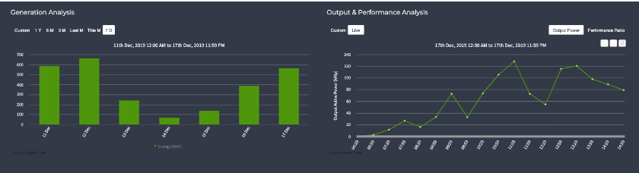

[Performance Analyzer](https://afourtech.com/remote-monitoring-solar-pv-unit/#:~:text=PERFORMANCE%20ANALYZER)

Performance metrics and fault diagnosis. Configurable performance thresholds and actionable alerts/Notifications.

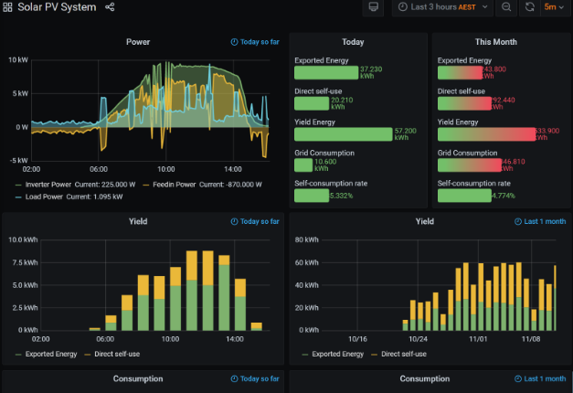

[System Dashboard](https://afourtech.com/remote-monitoring-solar-pv-unit/#:~:text=monitoring%20%26%20actionable%20solutions-,SYSTEM%20DASHBOARD,-Monitor%20multiple%20inverters)

* Configurable multi-level actionable email, SMS alerts & Notifications.
* Actionable output & Real-time analysis will ensure minimal efforts for maximized output.
* Effective Cost saving due to minimized inverter downtime & maximized output.
* Monitor multiple inverters and devices at various locations from a single user interface.

[Custom Analytics](http://www.vortexenergy.in/solar-pv-monitoring-system/#:~:text=SCEP%2C%20SSL%2C%20Proxy)-,Custom%20Analytics,-Creating%20custom%20analytics)

Creating custom analytics hand over you the immediate insight into the progress in performance with creating specific indicators and analytics for performances. With the integration of verified weather forecast data, you can find forecast energy production. It hands over you the access to analysis of production losses comparing to the ideal data and based on that, you can create a tailored alert to track the underperforming plants. You can also track and categories factors that affect the plant performance.

Maneesha

# Services

Solar monitoring analysis involves the use of various technologies to collect and analyse data related to solar energy production. Here are some common technologies used in solar monitoring analysis:

[Solar Monitoring systems](https://trackso.in/trackso-solar/)

Solar Monitoring Systems: These systems include sensors, meters, and data loggers installed in solar power plants or individual solar panels. They measure parameters such as solar irradiance (incoming solar radiation), ambient temperature, panel temperature, and electrical parameters like voltage, current, and power output.

* Collect data from solar inverters & MPPT strings to give accurate insights into your plant’s performance.
* Get detailed insights in solar PV system by monitoring each string & identify anomaly instantly at the right place.
* Monitor energy meters to make sure energy transfer happens with minimum losses, else, identify anomalies instantly.
* Keep track of weather conditions at your plant location to understand or predict generation loss & get instant alerts.

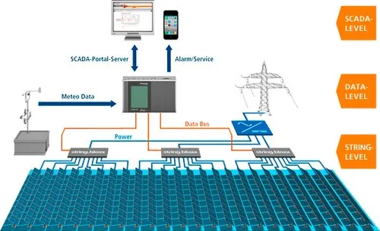

[Weather Monitoring](https://trackso.in/weather-monitoring-system-solar-power-plants/)

Weather Stations: Weather stations provide data on local weather conditions, including solar irradiance, temperature, humidity, wind speed, and direction. This data is crucial for understanding the performance of solar panels and assessing the impact of weather on solar energy generation.

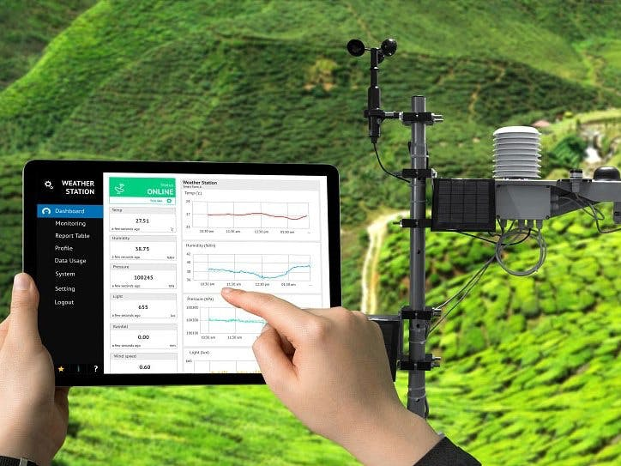

[Data Acquisition Systems](https://trackso.in/knowledge-base/data-acquisition-solar-systems-done-trackso-solar-platform/) Data Acquisition Systems: These systems are responsible for collecting and processing data from various monitoring devices. They often involve data loggers or data acquisition units that gather information from sensors and meters, store the data, and transmit it to a central server for analysis.

Monitoring equipment condition and identification of their performance. Improving the focus on predictive maintenance and reduce the downtime. Optimize plant asset lifecycle and assess asset failure impact. Access to decisions and solutions by domain experts. Ensure compliance to security and safety regulations.

Remote Monitoring and Communication: Remote monitoring systems allow real-time monitoring of solar energy systems from a central location. They use communication technologies such as wireless networks, cellular networks, or satellite communication to transmit data from solar sites to the monitoring centre.

Data Analytics and Software: Advanced software tools are used to analyse the collected data and provide insights into solar energy system performance. These tools may involve algorithms and machine learning techniques to detect patterns, identify anomalies, and optimize energy production.

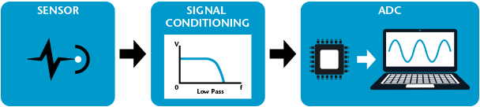

Sharath

# Services

We provide technology solutions for healthcare and government sectors. Our focus on **Remote monitoring and digital analytics** has helped us provide innovative solutions to clients across the world.

Experiencing frequent downtime with your solar energy system? Or

Having trouble tracking the performance of your equipment across multiple locations?

**Remote Monitoring System** is the solution.

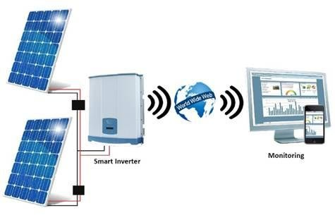

We provide various solutions with our Remote monitoring system to ensure that our client’s solar energy systems and other equipment are operating efficiently. With remote monitoring, we can track system performance in real-time and detect any issues that may arise. This allows us to address issues before they become major problems, reducing downtime and ensuring maximum system efficiency.

[24/7 PV Monitoring:](https://www.solarpowerworldonline.com/2014/09/command-control-247-solar-monitoring-matters%E2%80%A8/)

Our 24/7 PV system monitoring solutions help you to optimize the performance of the solar power systems, reduce downtime and maintenance costs, and ensure that your systems are performing at their best.

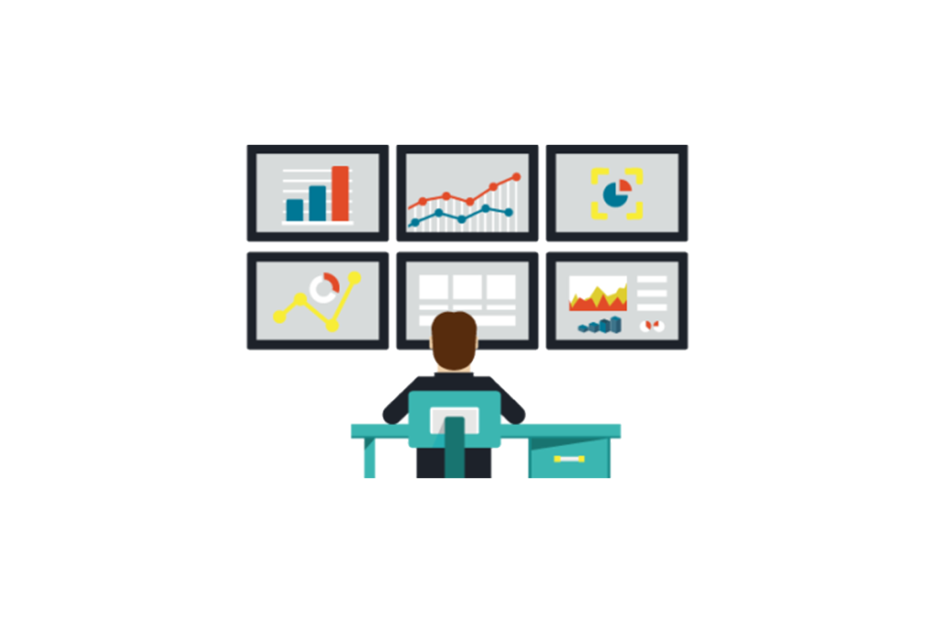

Using Our real-time inverter and performance graphing paired with our robust internal metrics, we will help you in:

* Immediate identification of issues and swift resolution. This helps to prevent downtime and ensure that the system is performing at its best.
* Provide detailed performance analysis of solar power systems, including metrics such as energy production, efficiency, and capacity.
* Proactive maintenance of solar power systems, with automated alerts for issues such as equipment failures or low production
* Remote troubleshooting and issue resolution, reducing the need for on-site visits and minimizing downtime.

[Troubleshooting & Repair](https://qesolar.com/services/troubleshooting-repair)



Each step in our process drivers us to maximize assets uptime. Leveraging our 24/7 alerts and response system, Intricate event analysis process, and proactive maintenance practices, we troubleshoot and repair without delay.

Experiencing higher-than-expected energy costs with its solar energy system?

We can help you identify areas where system upgrades could improve efficiency and reduce costs with our **Digital Analytics System.**

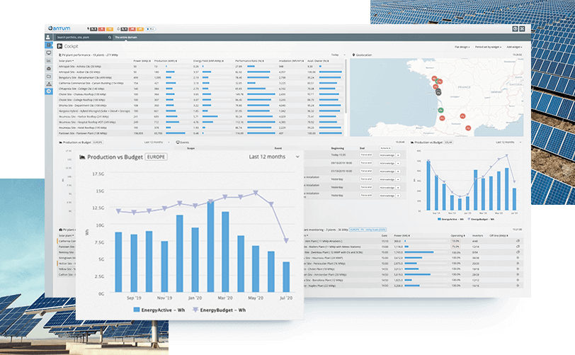

We provide solutions to help you analyse data from solar energy systems and other equipment. By analysing this data, we can identify patterns and trends that can help improve system performance and reduce costs.

[Leverage the power of customized analytics to maximize solar energy production](https://trackso.in/solar-pv-monitoring-and-analytics/)

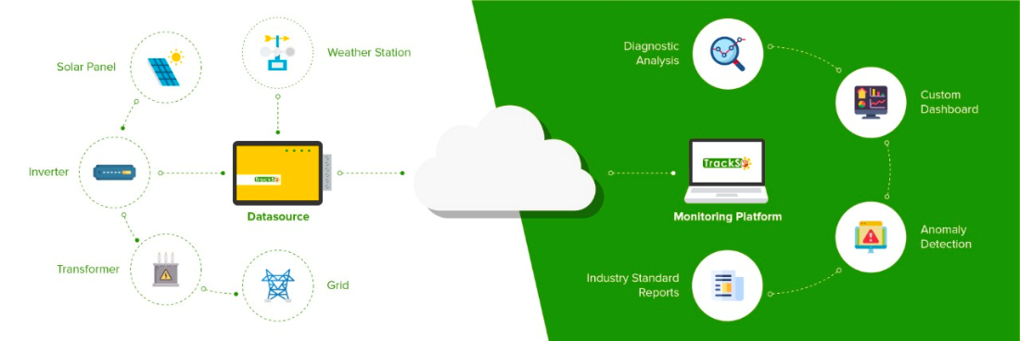

If you already have a monitoring system, our software seamlessly integrates to give you state-of-the-art Analytics – integral to Quadria's Digital Twin based approach.

All your portfolio data in one centralized cloud location – clean & analysis-ready

1. Accurate, specific, fully actionable O&M Guidance, in form of revenue quantified daily tickets with automated workflows.
2. Scalable, flexible deployment of your own data analytics libraries, KPI calculations etc. directly via Tableau, PBI, Python notebooks etc.

#### [Maintain your solar plants efficiently through Computerized Maintenance Management System (CMMS)](https://terotam.com/solar-energy-power) :

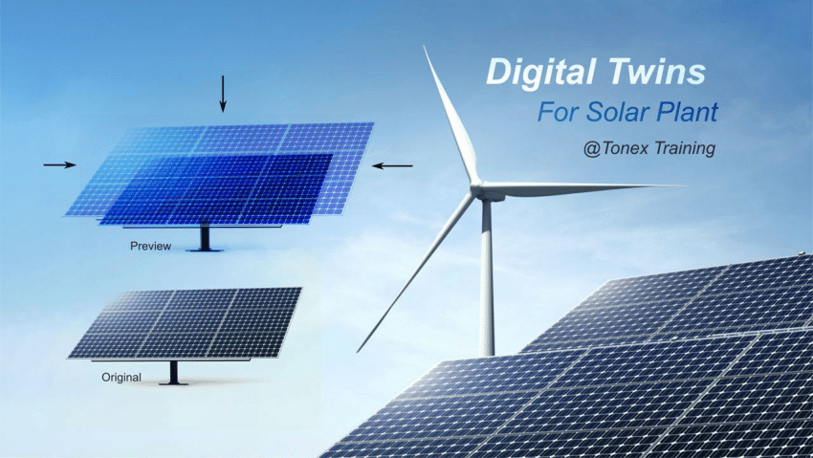

* We help you in better decision making, Improved maintenance planning, Increased equipment reliability, and Reduced maintenance costs.
* Digital Twin based CMMS can help teams collaborate better by providing a shared platform for asset data and maintenance activities. This allows for improved communication between different teams and better coordination of maintenance activities.

### [Power Forecasting:](https://solcast.com/blog/solar-forecasting/how-solar-power-forecasting-works-introduction-basics-FAQ-with-video)

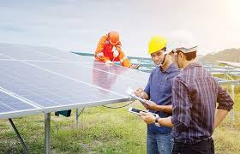

We provide highly accurate predictions of solar energy production based on advanced algorithms and weather data. This helps you to plan your operations more effectively and reduce the risk of production shortfalls. We also provide real-time updates on solar energy production, allowing clients to make timely adjustments to their operations based on changing conditions.

Key Features of our solutions:

* Reduced downtime for solar energy systems and other equipment.
* Improved system efficiency and performance.
* Cost savings through reduced energy usage and improved maintenance.
* Better decision-making through data analysis.

Yatin

# About US, Solution & Case Study

**What is real time alerting?**

<https://harksys.com/solutions/energy-monitoring/what-is-real-time-alerting/#:~:text=domestic%20energy%20meters-,What%20is%20real%2Dtime%20alerting%3F,-We%20use%20real>file:///C:/Users/LibsysAdmin/OneDrive - Libsys IT Services Private Limited/Documents/What is real time alerting.docx

We use real-time alerting to help drive efficiency in organisations. Real-time alerting is critical for empowering predictive maintenance and therefore reducing unnecessary maintenance callouts. Specific criteria can be set in The Hark Platform, and once the set thresholds are surpassed, an automatic message will be sent to the relevant person.

Alerts can have varying levels of severity and can be related to any variable, such as temperature, vibration, light, energy consumption, flow, pulse output and anything else you’re monitoring in The Hark Platform.

**How Does Real-time Alerting Increase Efficiency?**

Real-time alerting helps to mitigate asset malfunctions, production line issues and other kinds of critical events that could result in costly downtime. When an asset shows signs of heading toward failure, The Hark Platform will detect this instantly and ensure the right person is aware of how severe this issue is by sending an alert through Teams, Slack, SMS or Email (and more).

This kind of proactive approach to asset health and maintenance also minimises the need for manual checks and inspections, which increases cost efficiency.

On top of these operational performance advantages, there is a health and safety benefit to having real-time alerting too: faster response times mean that critical events are more easily mitigated and people working in the industrial environment are therefore better prepared and protected.

# What is Energy Monitoring?

## [Energy monitoring](https://harksys.com/solutions/energy-monitoring/) is the process of tracking, recording and visualising energy consumption, which can be across an entire facility or right down to an asset.

## Will Energy Monitoring Reduce my Consumption?

[Energy monitoring](https://harksys.com/solutions/energy-monitoring/) alone cannot reduce a facility’s energy consumption and provide instant savings, but it can provide detailed insight into a building’s operational needs for energy and facility managers to implement effective changes.

For instance, monitoring a building’s energy consumption could highlight inefficiencies such as excessively heating a vacant area or assets that are losing excess heat due to a possible failure. This identification of problem areas means changes can be made, such as conducting maintenance on assets that are operating inefficiently, meaning [energy savings](https://harksys.com/case-studies/smart-building-deployment/) can be gained.

Our energy analytics solution tracks energy consumption across your entire facility in real-time. We offer a full range of [connectivity solutions](https://harksys.com/product/) for monitoring consumption and generation.

Our platform analyses data from every connected component in your building to identify anomalies and areas for efficiency improvement.

Managers can access this information on our easy-to-use dashboard at any time, helping to make informed decisions. The Hark Platform can be instrumental in [driving down costs](https://harksys.com/case-studies/revolutionising-retail/).

# Why is Energy Monitoring Important?

## Accurately Measuring

When you look at a utility bill, it provides a final amount of usage and cost, broken down only by electricity or gas. Yet, it cannot directly tell you where the usage came from or the reasoning behind the different costs each month. Subsequently, it doesn’t provide energy managers with the appropriate information they need to make data-driven decisions.

## Identify Issues

According to the [Carbon Trust, typically 20% of all business’ annual energy costs are wasted](https://www.carbontrust.com/) through the use of inefficient equipment. Effective energy monitoring on a granular asset level continuously monitors equipment’s performance and energy output and instantly recognises when an asset is not operating efficiently.

## Real Time

Energy monitoring becomes even more effective when it is conducted in real-time. As soon as an asset breaks down, instant notifications can be sent to the maintenance team to rectify the situation before excessive amounts of energy is wasted. In addition, the [continuous monitoring and analysis of equipment data](https://harksys.com/solutions/remote-asset-performance-monitoring/) means [predictive maintenance](https://harksys.com/solutions/predictive-maintenance/) can take place, so assets can continue to operate efficiently at all times with fewer failures. Reducing the cost of factory downtime.

## Spikes and Dips

The continuous monitoring of energy consumption provides a daily breakdown of energy usage and makes it easier to identify trends and spikes. By reviewing energy trends over the course of the day, energy managers can determine the best solutions to reduce consumption and possible scheduling options to minimise usage during predicted spikes, such as going off-grid. Real-time energy monitoring is completely scalable, meaning you can monitor one building or an entire estate of facilities.

## Cost Per Unit

Monitoring real-time energy data also provides energy managers with better insights into cost per unit of energy. This metric helps organisations to reduce costs in demand or power factor.

If you would like to find out why real-time energy monitoring is vital to your business, then [get in touch](https://harksys.com/contact/), we can provide the tools to help you improve efficiency, maximise yield and reduce waste energy consumption.

# What Are The Benefits Of Energy Management?

An energy management system involves implementing a systematic and proactive approach to energy efficiency that is driven by energy monitoring data. Ultimately, energy management is the key to conserving energy and saving money.

Below are just a few of the benefits that can derive from implementing a stringent energy management system:

## Significant Energy Savings

With the organisation and its personnel taking a proactive approach to [monitoring energy usage](https://harksys.com/solutions/energy-monitoring/) and resolving any anomalies that cause energy wastage, the business will be able to drive down consumption and therefore bills.

## Improve Facility Performance

By operating a strict energy management system you are continuously monitoring all areas of your facility from HVAC systems to lighting. So, if there are any failures or weaknesses, they can be rectified instantly, so your facility is always operating at an optimum level. In addition, this proactive approach has also shown to reduce maintenance costs.

## Reduce Carbon Emissions

When implementing energy management, you are not only driving down consumption, you are significantly reducing carbon emissions. This is key in helping businesses reach their sustainable policy goals.

## Strengthen

Having greater control over your energy consumption means your business will be more resilient against energy price fluctuations. Particularly if you plan to implement a micro-grid or automation of assets.

## Measure Results

Not only will you will be able to see the result on your latest energy bill; you will be able to measure them. Consistently monitoring all areas means you can track improvement over-time, which is integral to help refine future business decisions. Our energy monitoring solution also utilises machine learning based analytics and forecasting technology to take your optimisation to the next level.

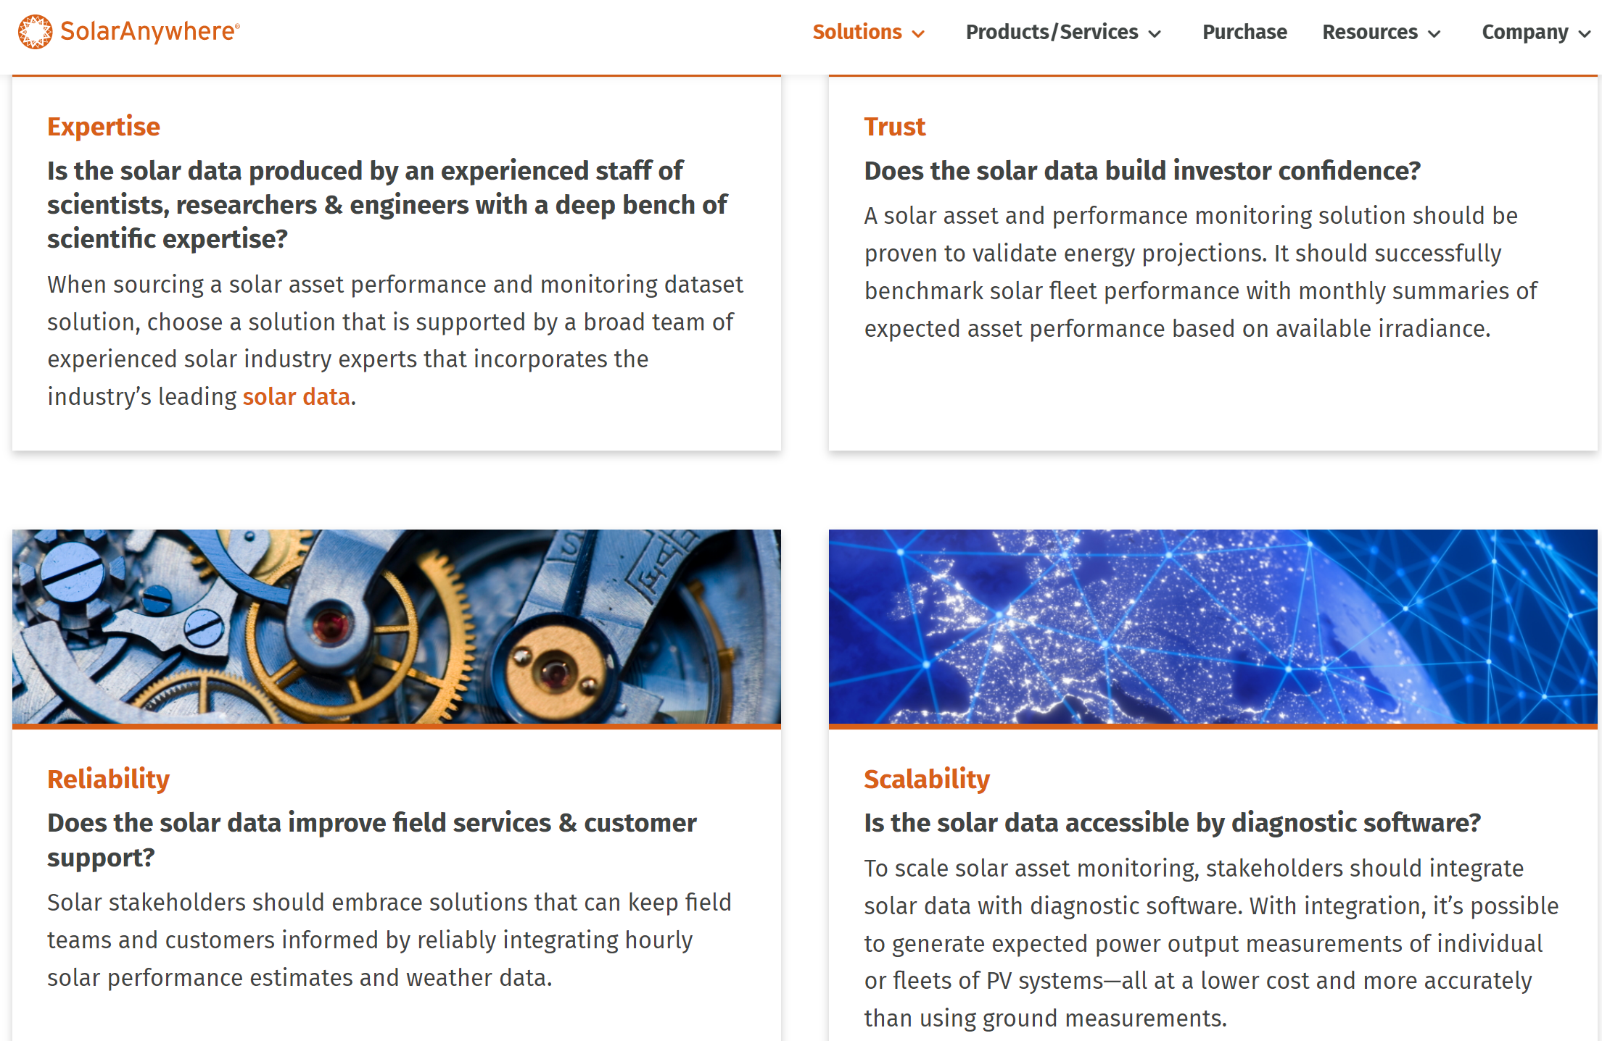

# What is peak load analysis?

<https://harksys.com/solutions/energy-monitoring/what-is-peak-load-analysis/>

Peak load analysis is a process of identifying the maximum amount of energy demand for any particular estate. It’s also a key part of resource planning and management for power grids, data centres, and other systems. Understanding peak load gives large estates the ability create a baseline for consumption and contextualise energy costs in association with grid demand.

## How Does Peak Load Analysis Work for Power Grids?

Electricity consumption can fluctuate throughout the day and varies by season – with the most intensive energy consumption taking place in winter. During peak hours, usually 8am – 10pm, the demand for electricity can exceed the supply, which will result in blackouts. Utility providers need to ensure that they have enough capacity to meet the peak demand while maintaining a reliable power supply.

During times of peak demand, electricity prices can increase, meaning it’s important to understand and analyse high-energy consuming assets and make sure they’re being used efficiently, in line with times of lower demand.

For power grids, peak load analysis involves analysing historic energy data and weather patterns to identify periods of peak demand. This information can help utility companies plan for the necessary capacity increases, such as building new power plants or upgrading transmission lines.

## Why is Peak Load Analysis Important? 💻

Peak load analysis helps to ensure that systems and assets can handle maximum demand without sacrificing any efficiency. By identifying peak demand periods and understanding peak load, large corporates can operate more efficiently and save on costs. Peak load analysis provides a benchmark for maximum consumption, which can also act as a target for energy reduction.

# Real-time Cloud Connectivity for Large Scale Solar InfrastructureEnabling real-time inverter connectivity

The estate contains a mixture of Mastervolt and Fronius inverters which communicate via different protocols including Modbus, MQTT and their own proprietary protocols. Each site has between 4 and 40 individual inverter units with the inverter power ratings between 4 – 10kW per unit.

Hark designed and deployed a solution using their Intel® IMRS cloud technology platform that enabled the organisation to stream real-time data at 1-minute intervals or less to the cloud with extremely low latency enabling real-time monitoring and automated actions based on predictions, faults, and changes in the performance of the asset.

The system utilised off-the-shelf gateway technology where the Hark Platform software was deployed to for edge connectivity, connecting to the inverters by TCP/IP communications and serial RS-485 communications.

The Hark Connect cloud and edge components running in Microsoft Azure then enable integrations with other Microsoft Azure cloud services, such as Azure Data Lakes, Storage, Web Apps and Microsoft Teams.

The plug and play integrations enabled the end-customers teams to utilise IoT services, APIs, and event streams to further build their own applications faster and more streamlined than previously thought possible. The Hark Platform software components were deployed to the customers Microsoft Azure tenant enabling the use of other Microsoft Cloud services with minimal development effort.Simplified and Extensible Connectivity, Data Aggregation and Cloud Integrations

Each array brought online added more real-time data to the organisation’s feed, which automatically scaled up, which provided a single aggregated feed of the data to the end-customers teams.

As generation and storage assets are deployed closer together as part of integrated grid and power solutions, the ability to extend and provide edge intelligence alongside other assets was paramount.

Hark’s primary goal is ensuring open protocol, secure and agnostic edge, and cloud platform architectures with our customers. This enables faster innovation and deployment of new technology services while ensuring minimal technical debt.

**The end customers are now able to build their own applications on top of a secure device connectivity platform, enabling new services and revenue streams.**

## Key Business Drivers There were several key business priorities driving the initiative

**Energy and Generation Data**

Access to high-fidelity real-time energy and generation data that can be used to provide insight into generation opportunity, weather, and cloud cover interactions and thus pipe data into advanced forecasting models.

**Maintenance and Operational Data**

Real-time status and performance information such as power, temperature, fault codes can be used by maintenance teams to power automated actions with minimal manual intervention. Key areas of concern were efficiency of the system, damage due to overheating, and complete and total failures of systems.

**Extensible Architecture for future ROI**

Deploying a future-proofed solution that can serve the needs of the Facilities, Operations and Technology teams for the next 10 years. As new technology becomes available, avoiding rewrites and maintaining velocity on features and improvements.

*“Solar inverters historically can be a challenge to cost-effectively connect to and optimise, given the type of asset they are. As the world moves to a data-driven economy, setting up the foundations to enable new innovation, revenue streams and applications is the key to success.”*

Mike Jeffs

CCO - Hark

*“Simplifying cloud connectivity for industrial assets is paramount for our organisations and teams to enable the net-zero transition. This provides a secure, future-proofed foundation.”*

Jordan Appleson

CEO - Hark

**Predictive maintenance** <https://harksys.com/solutions/>

**Predictive maintenance**

Commercial and industrial assets require constant upkeep to fully maximise their performance. Predictive maintenance software allows organisations to optimise their assets and maintain them efficiently – reducing waste and maximising yield.

## **What is Predictive Maintenance?**

Predictive maintenance is the act of monitoring data from assets in order to pre-emptively act on signs of deterioration, before they become problematic. Using tools like The Hark Platform, energy managers and asset operators are able to gain visibility of their entire estate and proactively maintain and repair damages before serious failures occur. This massively increases asset life, while reducing downtime and cost.

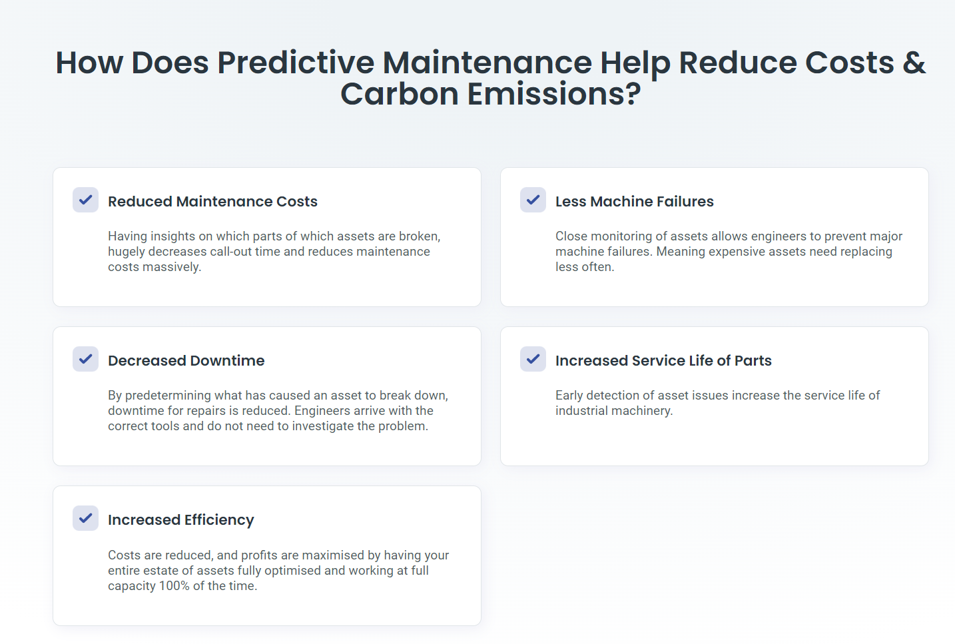

# Remote Asset Performance Monitoring

Connecting to, monitoring and optimising assets, from anywhere, at any time. Use Hark (an Intel® IoT Market Ready Solution) IIoT technology to stream your data to the cloud and visualise with beautiful custom dashboards.

## **What is Remote Asset Monitoring?**

The Hark Platform gives you the tools to spot anomalies in cost and asset operation, with alerts and notifications to help you prioritise maintenance. With remote asset monitoring you can enable predictive maintenance, therefore reducing operational costs, increasing efficiency and helping you reach your net zero targets.

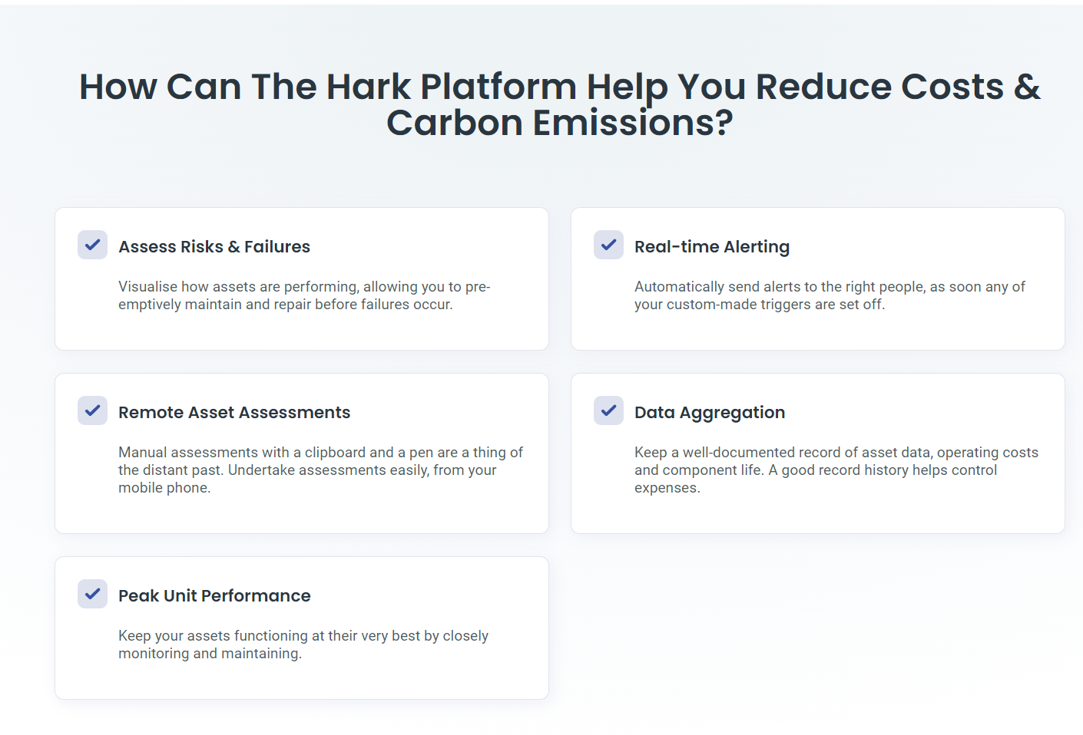

# Energy Consumption Monitoring and Management Software

The future of Energy Management is here; your power draw information – in real-time. Operational energy efficiency is key in every industry, and the Hark Platform helps facilitate the reduction of energy costs through real-time energy monitoring.

## **What is Energy Consumption Monitoring?**

Energy monitoring is the process of tracking, recording and visualising energy consumption, which can be across an entire facility or right down to an individual asset.

By monitoring energy consumption, and having access to critical data, we are able to fully understand operational weaknesses, and become empowered to make critical business decisions to cultivate change and ultimately reduce costs and emissions.

Monitoring and managing energy consumption promotes constant optimisation and gives users the tools they need to create a maximum-impact energy management strategy.

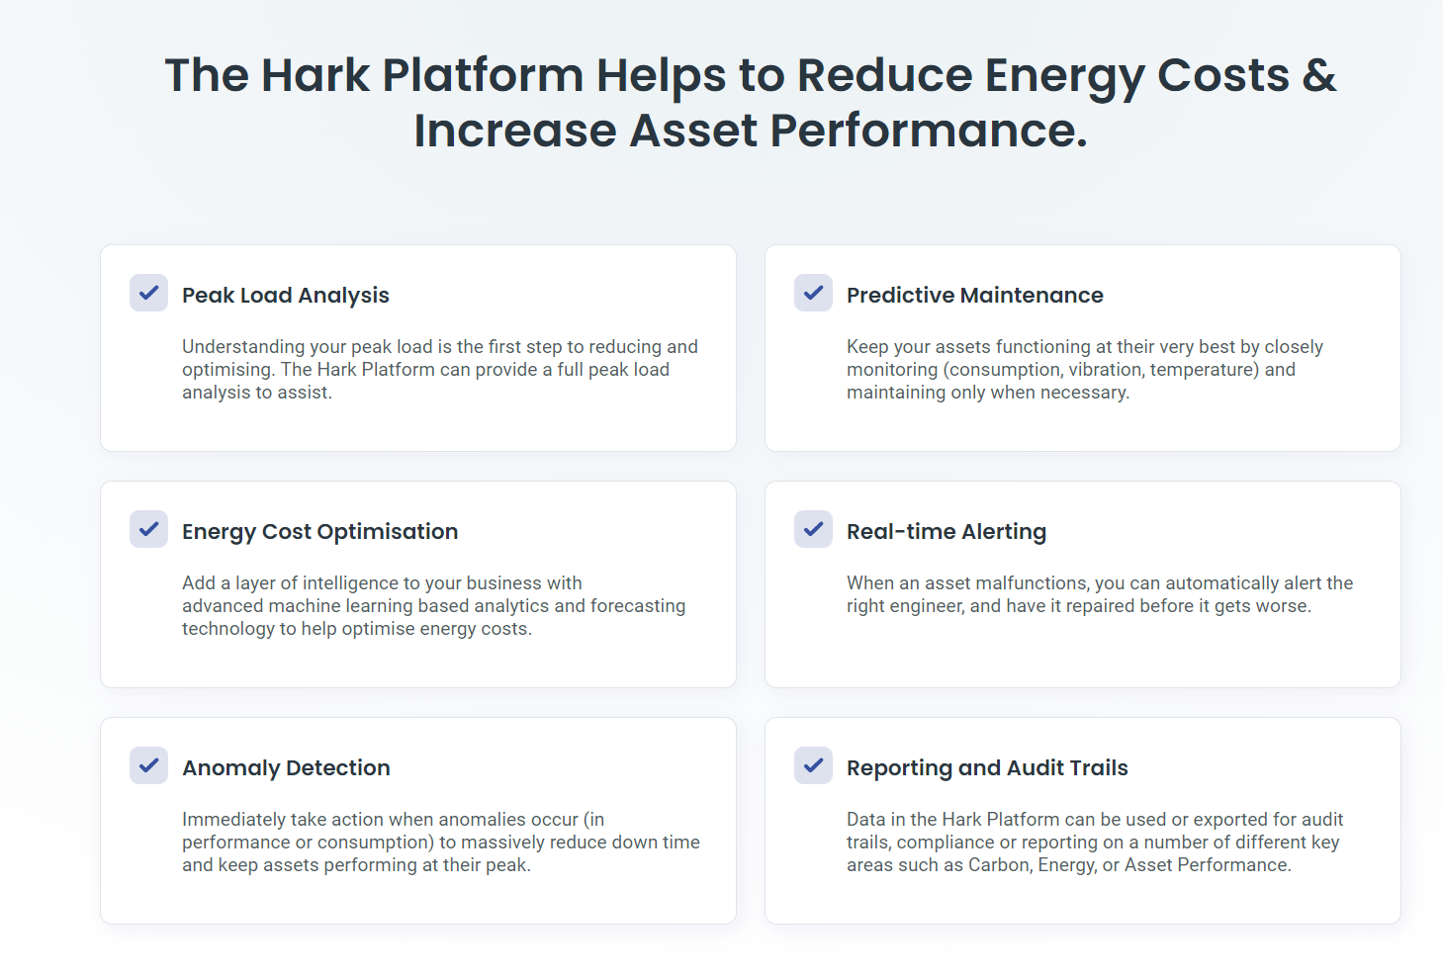

## Reducing Carbon Emissions with Industrial Asset Connectivity By connecting devices and assets, we can effectively reduce our carbon emissions output. That means that net-zero targets can be met, and we can help protect the planet.Here are some of the ways The Hark Platform cultivates sustainability:

* Efficiency of assets
* Reduced energy consumption
* No unnecessary maintenance call outs
* Remote energy assessments

# IoT Device and Asset Connectivity

Use Hark (an Intel® IoT Market Ready Solution) to connect industrial assets and stream critical data to highlight patterns in consumption. Connected assets massively increase efficiency by enabling digital asset visibility and remote device control.

## **What is IoT Device and Asset Connectivity?**

By securely connecting industrial devices, assets and sensors on the edge, in the cloud and on-premises, we can empower huge improvements to the way an estate performs.

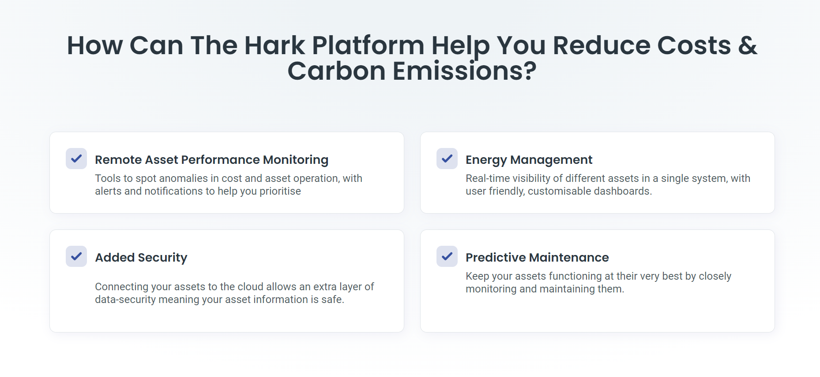

# Analytics

[Hark Analytics - Hark (harksys.com)](https://harksys.com/products/hark-analytics/)

## What is Hark Analytics

Hark Analytics empowers the visualisation and analysis of data from industrial assets, building management systems, and other sensors to monitor and report in real-time. This data can be democratised for operational directors, asset operators, engineers, analysts, and data teams.

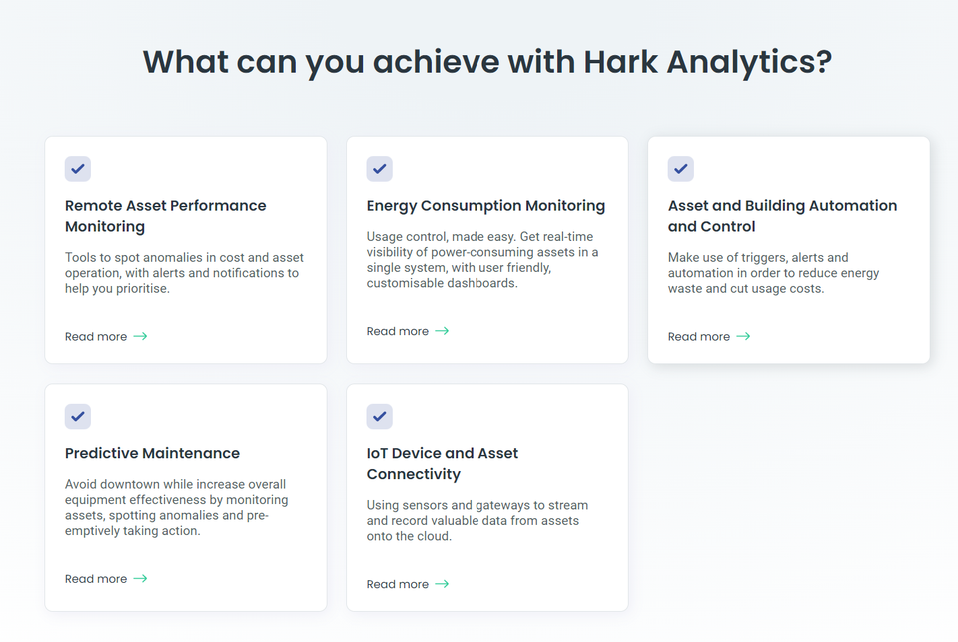

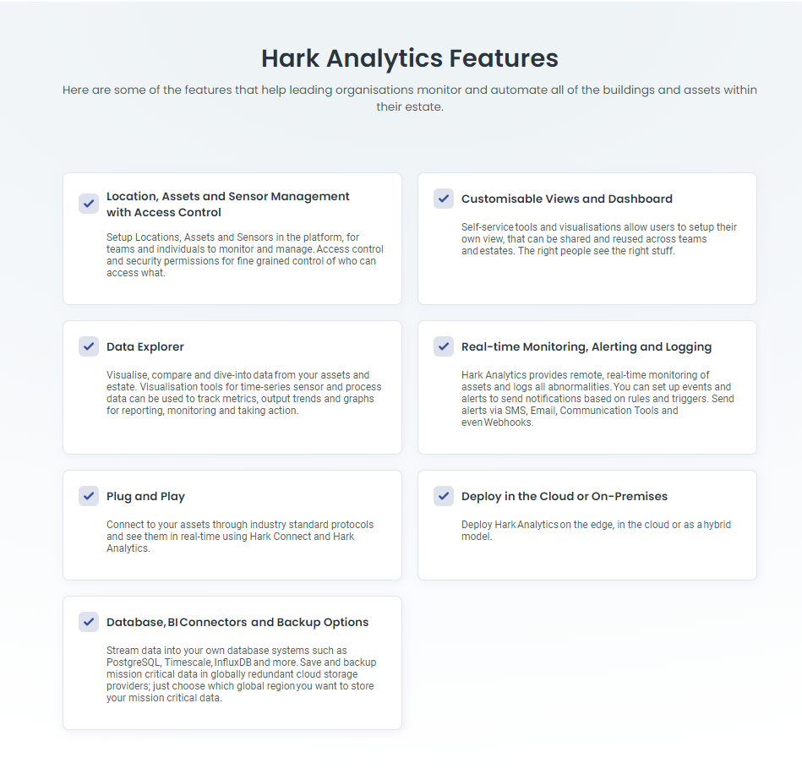

Solution

### **The Quadrical Plant Audit with Digital Twins**

Diving deep into the data, of 1 of your plants – the underperformer or a potential acquisition, we give you a comprehensive 3 – Month, performance assessment with Quadrical’s proprietary Digital Twins.

Find Issues much earlier, before they become a larger problem.

* 360° performance check based on 1 year of historical data
* Hassle-free, hardware-independent data transfer & deployment
* 5 Day Time to Value

Report Card with Automagic Identification & Analysis of hidden losses and underperformance due to Ongoing (long-term) & pop up (short-term) issues.

Historical & current production losses, leaky losses & anomalies with granular loss buckets (DC, Inverter & AC)  
• Identify ‘Late Starters,’ ‘Early Finishers,’ even ‘Mid-Day Slackers’ reducing  
generation

Proactive Recommendations to halt losses, improve generation capacity and scale up revenue  
• What to address first, before it becomes bigger  
• What may need to be flagged up to manufacturer or EPC

**Robust Benchmarking**

Activate Site O&M directly via Revenue Quantified & Prioritized Tickets

Available as interactive Audit Results Dashboard or PDF

Add on:  Quadrical ROC supports your O&M team for ticket accuracy verification and remediation

High RoI, no risk or disruption of current systems while also sensibly managing your data quality & security make this an easy choice to help O&M teams, Asset Managers and Developers run their plants at optimal potential and Investors do a quick sanity check to ensure their plants are being well run.

Making that maintenance customized and intelligent, in RealTime, with Predictive & Condition based Maintenance, will help them reach optimal performance levels faster.

**Download**[Factsheet](https://www.quadrical.ai/wp-content/uploads/2022/07/Plant-Audit-Factsheet-1.pdf)**| Watch**[Video](https://www.youtube.com/watch?v=9BLvnj2oXuk&t=1s&ab_channel=QuadricalAi)

### **Digital Twin based CMMS**

Your entire, global portfolio – more easily managed – on a trusted, cloud-based platform.

Integrate plants and equipment communicating on different protocols, across different assets into 1-single page view, **1 single truth source**.

1. **Data aggregated** from a wide variety of critical sources— SCADA, other Data Acquisition Systems, to power forecasts – with zero sync issue, state-of-art cloud storage and data archiving solutions. **Standardized data migration** process, managed by Quadrical Technical Team
2. **Centralized Data Platform** with built-in Monitoring/Reporting and Advanced Analytics
3. Expert support to ensure a RealTime assessment of plant performance across your complete portfolio
4. View and act on **Revenue Quantified and Prioritized Automatic Tickets** across:  
   • Alerts & Outages  
   • Preventative Maintenance & Predictive Maintenance, with accurate Needle-In-Haystack  
   **• Condition based Maintenance**
5. Condition based Maintenance streamlines O&M and ticket management in a single workflow with  
   • RealTime static, dynamic & progressive alerts  
   • Portfolio-wide standard schema  
   • Actionable and revenue prioritized ticketing

All together, these provide real intelligence built into a Monitoring Platform with Predictive O&M Guidance which continues to become more intelligent with time, to guarantee maximum ROI

**Download**[Factsheet](https://www.quadrical.ai/wp-content/uploads/2022/07/Digital-Twin-Based-CMMS-Factsheet-1.pdf)

### **Snap-On Advanced Analytics**

If you already have a monitoring system, our software seamlessly integrates to give you **state-of-the-art Analytics** – integral to Quadrical’s Digital Twin based approach.

You get what we’re known for – the ability to deliver real dollar value by driving performance

* All your portfolio data in one **centralized cloud location** – clean & analysis-ready
* Accurate, specific, fully actionable O&M Guidance, in form of **revenue quantified daily tickets** with automated workflows
* Scalable, flexible deployment of**your own data analytics libraries**, KPI calculations etc. directly via Tableau, PBI, Python notebooks etc.
* Seamless transfer of Digital Twin generated tickets into your existing ticketing system, using API-based data transfer

Insights only Quadrical can mine, via unique Data Intelligence, based on ingesting data from a variety of critical sources. This means Advanced Digital Twin technology based Predictive Analytics + your own RealTime Monitoring to help drive O&M excellence leading to real dollar value.

* Loss bucketing and issue prioritization by revenue impact
* **Actionable, automated Revenue Prioritized Ticketing**
* **Accurate Needle-in-Haystack** – Degradation Tickets for short term ‘pop up’ issues
* Anomaly & Outage Prevention – Automatic detection of early signatures of underperformance (soiling, shading, string level outages)
* **Self-Serve Advanced Data Analytics**

All on RealTime dashboards, which deliver real RoI. Value and insights, from Digital Twin AI allow for 2 – 4% increased generation /15% greater O&M efficiency.

Hardware Independent. Fully Extensible.

**Download**[Factsheet](https://www.quadrical.ai/wp-content/uploads/2022/07/Snap-On-Advanced-Analytics-Factsheet.pdf)

### **Power Forecasting**

Make your internal planning and regulatory compliance stronger. Accurately forecast future production on our platform with **> 98.4% accuracy** in head-to-head tests.

* **Intra-Day**, **Day(s) Ahead**, **Week(s) Ahead**
* Optimized database tailored to **every required location**
* Ensemble of **multiple weather providers** for greatest accuracy
* **Storage, Trading & Pricing Optimizations**

Available ONLY as Add-On to Digital Twin based CMMS

### **Remote Operations Centre (ROC)**

As you have a fast-growing portfolio to manage, leave the Remote Operations to us.

Optimize your O&M with **365, 24/7 support** with **continuous, RealTime monitoring, in-house performance engineering, and proactive service**.

Together with our Digital Twin based Asset Performance Management Platform, Quadrical ROC can scale up seamlessly to deploy **Advanced Remote Operations** for any project, anywhere.

We help you,

* Triage Issues
* Minimize turnaround time for Site O&M
* Coordinate Execution & Post-Fix Follow Up
* Mitigate risk through RealTime fault reporting and incident prevention

Available ONLY as Add-On to Digital Twin based CMMS and Snap-On Advanced Analytics

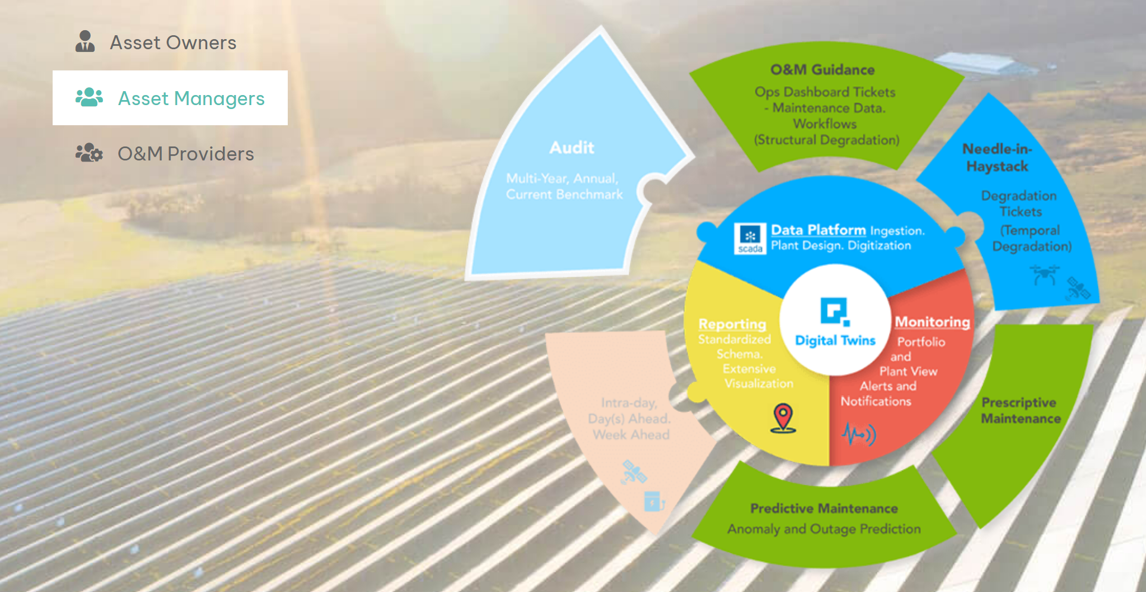

## Plant Performance Assessment

We at Apollo, we don’t just build Software, we are here to solve the customers pain points. We independently assess the plant performance with the help of our experts and generate actionable insights reports for performance improvements and performance audits. We have partners globally who support us with on-field inspections, specialized testing and deep domain expertise. Avail specialized services such as asset residual life and failure prediction,string failure analysis, Flash test, Oil tests, PV module year-on-year degradation analysis, soiling optimization and much more.

#### Custom Reports

Apollo allows you to build your own reports from the tool itself. However, if you need something specific - your logo, your format, your report template - we got you covered. We create custom reports in excel and PDF format for stakeholders like CXO, Asset managers,Customers, Operations teams, etc with interactive charts. Never receive a delayed report and all on time via automatic share via email to all recipients.

Key Features

## Predictive Analytics

Apollo’s patented Digital Twin, AI and ML powered platform uses pre-trained algorithms to identify the potential gain areas and troubleshoots the key areas of plant underperformance increasing the output by ~7%.

### Apollo™ energy analytics has a Patent on the Solar PV Digital Twin

The Digital Twin (DT) technology is an electrical replica of the Solar PV plant and for the current weather conditions - the DT generates the optimum Active power that the plant should generate for the given conditions. It does the same at disaggregated levels which means it starts at the Inverter level and adds it up, hence allowing you to know exactly which devices are not performing up to the mark.

#### Insights and opportunities

Track portfolio wide KPIs for solar and wind to get insight on ongoing performance & monitoring it easily to detect areas for optimization or underperformance with advanced analytics suite.

#### Loss Bucketing

Reveal the factors behind each segment of the Waterfall and unlock significant gains in the output of the Asset. Whether it is loss on account of repeat failures, soiling, efficiency issues, shading, clipping, power factor, unavailability, be the first one to know automatically.

#### Performance Reports

The Apollo performance reports enable high automation for Asset Owners by sending pre-configured reports to the relevant stakeholders as desired. Be it an Failure prediction alert or a performance summary we do all of it.

#### Alerts and anomalies

With customizable alerts and AI trained models, Apollo detects critical issues before you could raise your eyebrows. Our sophisticated predictive solar maintenance analytics models, based on AI, are designed to highlight possible Inverter or Transformer failures, anomalies, or deviations weeks in advance - making sure you are always in control and ahead.

Dileep

# About Us & Solution

[Omnidian](https://www.omnidian.com/)

[Why Omnidian? Why Now?](https://www.omnidian.com/#:~:text=Why%20Omnidian%3F%20Why%20Now%3F)

[Set It and Forget It](https://www.omnidian.com/#:~:text=Set%20It%20and%20Forget%20It)

Omnidian’s award-winning team knows solar systems. We monitor our clients’ systems 24/7 and remotely diagnose issues. If there’s a problem that needs your attention, we’ll call you—and get to work to make it right.

[Performance, Guaranteed!](https://www.omnidian.com/#:~:text=Performance%2C%20Guaranteed)!

We provide performance assurance for solar investments, from single systems to large portfolios. We can even guarantee annual energy generation.

[Intelligent System Diagnostics](https://www.omnidian.com/#:~:text=Intelligent%20System%20Diagnostics)

Omnidian’s services are powered by industry-leading technology enabling issue detection and diagnostics. Shading or soiling? Weather or component failure? Our algorithms remotely identify the root cause. Our experts handle the solution.

[Transparency and Control](https://www.omnidian.com/#:~:text=Transparency%20and%20Control)

Personalized reports track energy generated taking into account real-world factors, like weather. You’ll always know how your investment is performing, and why. Your return is optimized with 24/7 monitoring and rapid remote diagnostics.

[Expert Support](https://www.omnidian.com/#:~:text=free%20client%20experience.-,Expert%20Support,-We%20know%20about)

We know about system issues, often before you do, and we’ll contact you if your system requires attention. And if you have any questions, our team of solar experts are a call or click away.

[OUR STORY](https://www.omnidian.com/our-story/)  
  
[Engineering End - to - End Peace of Mind](https://www.omnidian.com/our-story/about-omnidian/#:~:text=Engineering%20End%2Dto%2DEnd%20Peace%20Of%20Mind)

**Engineering End-to-End Peace Of Mind**

What sets Omnidian apart is that we’ve engineered a powerhouse peace-of-mind experience by committing ourselves to unparalleled excellence in three areas:

* **People**. We hire people who are *passionate* about the Omnidian family, the customer care experience, and the global community. That’s why Omnidian has been named one of the *Top 100 Places To Work* for three consecutive years.  Our culture, service commitment, and ethical standards are second to none.
* **Technology**. We develop innovative technology that goes far beyond traditional monitoring. Our service teams have 24/7 access to your solar system’s performance, and our advanced remote diagnostics identify underlying issues (like snow, soiling, or component part failures). When we call you, we’re already working on a solution to provide you with a hassle-free ownership experience and a guaranteed return on your investment.
* **Customer Experience**. We are obsessed with delivering the most amazing customer experience. In fact, service excellence is our crown jewel and how we maintain one of the industry’s highest 5-star ratings.    Our clients tell our brand story for us.  
    
  [About Omnidian](https://www.omnidian.com/our-story/about-omnidian/behind-the-scenes/#:~:text=a%20Sales%20Exec-,About%0AOmnidian,-Omnidian%3A%C2%A0%20Behind%20the)

[Our Inception: The Industry at a Point of Inflection](https://www.omnidian.com/our-story/about-omnidian/behind-the-scenes/#:~:text=Our%20Inception%3A%C2%A0%20The%20Industry%20at%20a%20Point%20of%20Inflection)

In 2016 a team of three solar vets launched a dream.  While the industry was focused on rapidly accelerating residential and commercial solar sales, the industry’s response to performance issues was capsulated with two letters:  O&M.

O&M meant that when, and if, system performance problems were detected as a general rule the original seller would address the issue under existing manufacturer warranties.  The problem was two-fold.  First, time.  O&M issues tended to be prioritized behind new sales.  Secondly, a lot of original sellers were disappearing in a cloud of business failures and bankruptcies.

The industry was facing a significant and growing fracture:  the post-purchase experience.  Institutional buyers holding large portfolios of solar leases – and homeowners who were stranded following bankruptcies – were losing the return on their investment from both system failures and long-term under-performance which remained largely undetected.

The long-term confidence in renewable energy investments was likely to deteriorate over time. Omnidian’s mission was formed:  to protect and accelerate investments in clean energy technology.

[The Dream](https://www.omnidian.com/our-story/about-omnidian/behind-the-scenes/#:~:text=clean%20energy%20technology.-,The%20Dream,-The%20original%20founders)

The original founders spanned all facets of industry expertise.  Their experience in solar included leadership positions in operations, capital management, and national and international new market entries.

**They began to ask themselves a set of ‘what-ifs:’**

* What if: we built the technology and the team to eliminate responsive O&M calls, and replaced the experience with remote issue detection and proactive customer care?
* What if: we could actually identify, remotely, the root causes of issues and the portion of energy deterioration associated with each?  It made sense, after all, in the real-world system issues often overlap one another.
* What if: we could build a team with an obsessive focus on service, customer care, operational excellence?

**Omnidian was launched.**

Well, sort of.  The original name of the company was PeGu.  Which was short for Performance Guarantee.

Off the founders flew to Southern California to meet with a long-time friend and one of the Top 50 Marketers in America.

In a conference room, they explored – not names – but company purpose.  The white board was filled with aspirations.

* The ability to launch remote performance diagnosis would depend on digitalization—the very foundation for machine learning. The mission:  to identify data patterns consistent with root cause performance issues.
* Any digitalized asset class could benefit from the technology and remote diagnostics. In other words, not only solar – but battery technology, HVAC – light bulbs!
* Finally, the new company was being formed to protect the performance of those asset classes.

The name of the new company came from PeGu’s head of Operations and was generated from a sea of naming concepts on the white board.  In fact, it is a mash-up – from Latin:  **Omni**(all things), and the role the newly formed company intended to play in the peaceful enjoyment of clean energy investments:  custo**dian**.

Omnidian was born.  Custodian – of all IoT things.

[*Building The Team*](https://www.omnidian.com/our-story/about-omnidian/behind-the-scenes/#:~:text=all%20IoT%20things.-,Building%20The%20Team,-Great%20people%20build)

Great people build their own job description and so the focus of the leadership team was not to tell people how to do their job – but rather to create the cultural framework under which everyone could thrive.   Those operational pillars included not only the [company’s values](https://www.omnidian.com/careers/our-values/) but also the targets of our collective efforts:

* **Innovative technology** custom-built by our solar vets and remarkable engineers working *side by side* to design the industry’s first white-glove, hassle-free clean energy ownership
* **Passionate teams** created in a culture where everyone is a respected “insider” who has the opportunity to be heard, to grow, to learn, and to have meaningful impact.
* And finally, the core of our mission: **The most** ***amazing* customer experience**. It’s a high bar, and we measure it after every single client engagement

[Ominidian Solutions](https://www.omnidian.com/solutions/)

[Commercial Owners & Operators](https://www.omnidian.com/solutions/commercial-and-industrial/solar-performance-assurance-commercial-owners-operators/#:~:text=Commercial%0AOwners%20%26%20Operators)

[Performance Assurance](https://www.omnidian.com/solutions/commercial-and-industrial/solar-performance-assurance-commercial-owners-operators/#:~:text=Omnidian%20Performance%20Assurance) Purpose-built AI-powered monitoring technology coupled with solar O&M expert support. An industry-leading asset performance management solution trusted by over 250 C&I solar developers, owners, and operators nationwide. We have custom-tailored solutions built for your unique needs.

[Protect Your Investemnt](https://www.omnidian.com/solutions/commercial-and-industrial/solar-performance-assurance-commercial-owners-operators/#:~:text=your%20unique%20needs.-,Protect%20Your%20Investment,-Get%20dedicated%20expert) Get dedicated expert support working with you to drive the performance of your solar assets—so you can rest assured that your clean energy investments are protected. Leveraging our proprietary technology, and our team of solar experts notifies you promptly the moment an issue is detected. When service is needed, your dedicated portfolio operations manager(s) will coordinate a rapid response via your team—or through our nationwide field service network—and ensure prompt resolution.

[*Move Beyond Traditional Monitoring*](https://www.omnidian.com/solutions/commercial-and-industrial/solar-performance-assurance-commercial-owners-operators/#:~:text=Move%20Beyond%20Traditional%20Monitoring) Our proprietary technology models performance by creating a digital twin of your assets and layering on live, satellite-derived weather data. Using machine learning and AI, we monitor your real-world assets for underperformance—while ingesting and filtering component-level alerts—to identify, diagnose, and drive remediation. By filtering out false or inactionable alerts, and remotely remediating more than half of all issues without human intervention, you only roll a truck when absolutely necessary, and ensure fast, focused issue resolution.

[Reduce Operating Expenses](https://www.omnidian.com/solutions/commercial-and-industrial/solar-performance-assurance-commercial-owners-operators/#:~:text=Reduce%20Operating%20Expenses) We manage monitoring, false alert filtering, remote diagnosis, service coordination, and field service partner relationships. And because we remotely diagnose issues, we reduce your truck roll cost by scheduling service visits only when on-site work is required. In fact, a recent analysis by our data science team showed a 60% reduction in corrective maintenance costs across our commercial solar portfolio.

[Remove Geographic Limitations](https://www.omnidian.com/solutions/commercial-and-industrial/solar-performance-assurance-commercial-owners-operators/#:~:text=Remove%20Geographic%20Limitations)

Our vetted nationwide field service network covers over 33,000 zip codes, giving you peace of mind that your solar farms are protected as you grow your portfolio. All operations and maintenance service work is coordinated and reviewed by our team for quality, so you’ll have peace of mind knowing your assets are in good hands. Take back your time while we protect your investment through managed preventative and corrective maintenance, as well as auxiliary services like vegetation management, panel washing, aerial scans, medium voltage management and QA/QC inspections.

[Scale Your Business](https://www.omnidian.com/solutions/commercial-and-industrial/solar-performance-assurance-commercial-owners-operators/#:~:text=QA/QC%20inspections.-,Scale%20Your%20Business,-With%20Performance%20Assurance)

With Performance Assurance, our solar experts become an extension of your team, so that you can focus on growing your PV pipeline. Omnidian’s turnkey solution means you have dedicated portfolio managers—backed by our team of engineers, data scientists, and solar industry veterans—tracking the health and production of your assets. Your one stop shop for guaranteed asset performance

[Streamline Reporting](https://www.omnidian.com/solutions/commercial-and-industrial/solar-performance-assurance-commercial-owners-operators/#:~:text=Streamline%20Reporting)

Take back your valuable time with easy access to centralized, standardized reporting for all system and performance data with consistent metrics across your entire portfolio. Our unified reporting covers all performance metrics and corrective & preventive maintenance reports, easing the burden of consolidating data from different systems and providers, providing reliable data at your fingertips, while helping to streamline financial and ESG reporting.

[Guarantee Performance](https://www.omnidian.com/solutions/commercial-and-industrial/solar-performance-assurance-commercial-owners-operators/#:~:text=Guarantee%20Performance)

We don’t just drive performance—we back it up with a 95% performance guarantee. If you opt to include this with a system, and it generates less than 95% of the annual energy we forecasted during testing, we’ll cover the shortfall. A case study with a prominent commercial solar developer showed a 14% increase in the average monthly performance index over six months.

[*Community Solar Solutions*](https://www.omnidian.com/solutions/commercial-and-industrial/solar-performance-assurance-commercial-owners-operators/#:~:text=Lower%20operating%20costs,Community%20Solar%20Solutions)

Omnidian is focused on maximizing solar farm production and value for C&I scale and Community Solar projects, delivering industry-leading asset performance management services for landowners and large scale solar asset owners and operators. We partner to help drive peak system performance and assure maximum utilization rate with your off-takers.

Thanks to our advanced, proactive monitoring solution, we’re able to identify potential issues before they become big problems. We have vetted technicians local to any project across the U.S. providing preventive and corrective maintenance, and auxiliary services including vegetation management.

You’ll have access to customized, real-time reports on key asset metrics, as well as a dedicated portfolio manager working with you to maintain your leading asset performance ratio; all backed by a 95% performance guarantee. We believe in driving holistic value for all project stakeholders.

[*Residential installers*](https://www.omnidian.com/solutions/solar-performance-assurance-residential-installers/)

[Portfolio Investors](https://www.omnidian.com/solutions/solar-performance-assurance-for-portfolio-investors/#:~:text=a%20Sales%20Exec-,Portfolio%0AInvestors,-Read%20Our%205)

[Residential-customers](https://www.omnidian.com/solutions/residential-customers/)